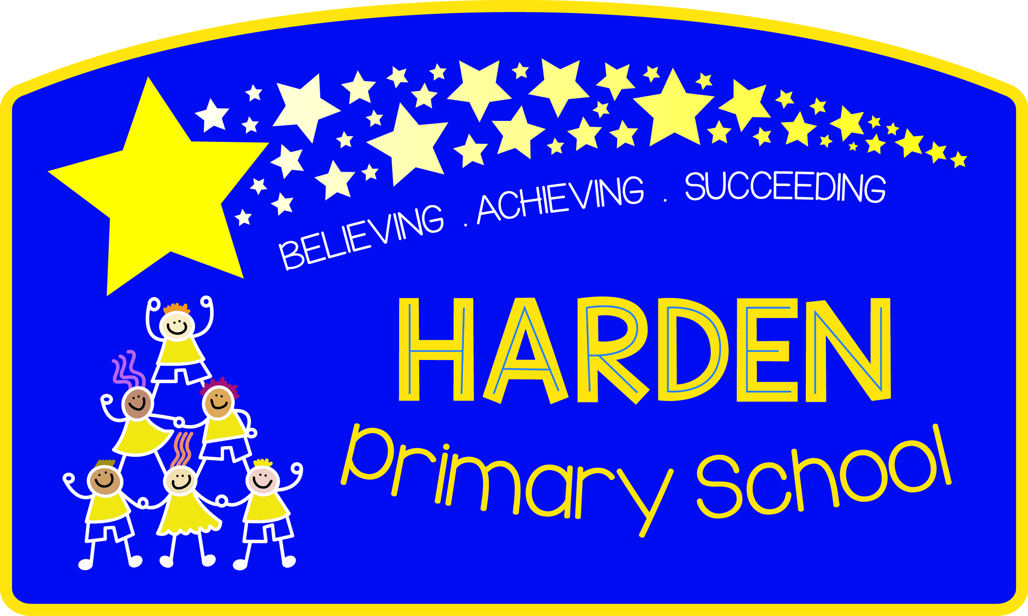

HARDEN PRIMARY SCHOOL
P.E. PREMIUM
September 2014/15

FUNDING:
During the current academic year Harden Primary received an allocation of £5438.00 in order to improve Physical Education and school sport.
HOW HAS IT BEEN SPENT:
This year’s funding has been used to hire specialist Physical Education teachers (Fisical) to cover staff Planning Preparation and Assessment (P.P.A) for 1 hour per week for all year groups between year 1-6. It has also been used to employ qualified sports coaches in a variety of Sporting disciplines to work alongside existing teaching staff in PE lessons and further enrich the PE curriculum offered to Harden Primary School pupils.
This approach was designed to act as a professional development exercise for existing staff as well as attempting to raise standards within the teaching of PE throughout the school.

Class | Developmental Sporting Activity
Year 1 | S.N.A.G Golf (5 weeks)
Year 2 | Chance to Shine Kwik Cricket (12 weeks)
Year 3 | Mini – Squash (6 weeks) & Festival
Year 4 | S.N.A.G Golf (5 weeks)
Year 5 | Sports England Uk – Football (6 weeks)
Year 6 | Chance to Shine Kwik Cricket (12 weeks) & Festival
 | Sports England Uk – Football (6 weeks)

IMPACT:
End of year assessment information has shown an increase in the number of pupils attaining ‘above expected’ levels for PE.
Evaluation of the effectiveness of the specialist coaches working alongside teachers indicated that these staff felt considerably more confident in the future delivery of these units of work.
A survey was also completed with all of the children working within these sessions in order to evaluate both the effectiveness of this year’s programme and to assist in deciding how best to allocate next year’s funding too.
Results from the children’s survey were that all of the qualified coaches who worked with the years 1, 2, 3, 4, 5 & 6 classes and staff were successful in delivering enjoyable, active and skill specific sessions. (See table below:)

 | Fisical  (All PE curric)  (Y1-Y6) | S.N.A.G (golf)  (Y1 & Y4) | Chance 2 Shine  (cricket)  (Y2 & Y6) | Sports Coach Eng UK  (Football)  (Y5 & Y6) | Heaton  Squash  (Y3)
Enjoyed/Really Enjoyed sessions | 88% | 90% | 90% | 91% | 100%
Found them Moderately-Very Active | 97% | 96% | 90% | 97% | 97%
Learned lots-some new skills | 84% | 95% | 94% | 57% | 100%

Finally, it is clear to see from the excellent results gained in this academic year from various primary school sporting events that prowess within Sport & Physical Education is certainly a strength of the school. Furthermore, it also goes to show that PE provision both within the curriculum and in extra-curricular activities are both having a major impact upon our pupil’s performance when compared with other primary schools. (See table overleaf:)

Extra Curricular Activity | Result
Year 5&6 Boys Football (Shipley & District League) | Runners Up (17 teams)
Year 5&6 Girls Football (Shipley & District League) | 3rd place (11 teams)
Year 5&6 Boys Football (Oakbank League) | Winners (19 teams)
Year 5&6 Girls Football (Oakbank League) | Winners (14 teams)
Year 3&4 Boys & Girls Football (Oakbank League) | Runners Up (16 teams)
Year 5 & 6 Boys Football (Bradford Park Avenue Cup) | Runners Up (18 teams)
Year 5 & 6 Boys Football  (BRADFORD schools FINALS) | Runners Up (100 teams)
Year 5 & 6 Girls Netball (Keighley Schools league) | Winners (12 teams)
Year 5 & 6 Girls & Boys Netball (Shipley & District Schools) | Winners (16 teams)
Year 5 & 6 Girls & Boys Netball  (BRADFORD schools FINALS) | Winners (65 teams)
Year 3 Mini Squash | Winners
Year 5 & 6 Girls & Boys Kwik Cricket (Oakbank schools) | Winners (7 teams)
Year 3 & 4 Girls & Boys Kwik Cricket (Oakbank schools) | Winners (9 teams)
Year 5 & 6 Girls & Boys Kwik Cricket  (BRADFORD schools FINALS) | Runners Up (50 teams)
Year 3 & 4 Girls & Boys Kwik Cricket  (West Yorkshire FINALS) | Runners Up (75 teams)
Year 5&6 Boys Cross Country  (Keighley Schools league) | Runners Up (15 teams)
Year 5&6 Girls Cross Country  (Keighley Schools league) | Runners Up (15 teams)
Year 5 & 6 Boys Football  (WEST YORKSHIRE YOUTH GAMES FINALISTS) | T.B.C – Tuesday 7th July @ Leeds Met University
Year 5 & 6 Girls & Boys Netball  (WEST YORKSHIRE YOUTH GAMES FINALISTS) | T.B.C – Tuesday 7th July @ Leeds Met University

NEXT STEPS:
Re-allocate part of next year’s funding to SportEngland Uk, S.N.A.G golf, Chance 2 Shine Cricket, Heaton Squash & Tennis club coaches to continue their good work alongside different classes throughout the school. Maintain the current emphasis upon staff working alongside these highly skilled individuals to further raise standards in PE for future years to come also.
Run specific extra-curricular school club(s) aimed at involving the least active and/or vulnerable pupils within Harden Primary School.
Continue to update & improve sports resources and equipment.
Fund training for year 6 sports leaders to attempt to improve quality of games & sporting provision during playtimes and lunchtimes.
Release current PE Co-ordinator to work alongside staff in order to further develop staff competence and confidence in the delivery of their physical education lessons.

