Friday 13th October 2017

Dear Parents,
Reception Curriculum update – end of Autumn 1
Phonics –
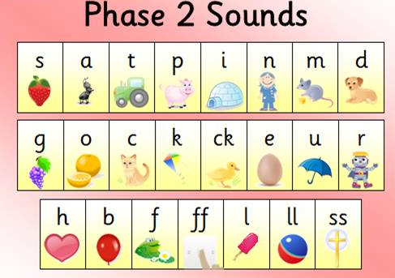
This week we have finished introducing the Phase 2 sounds (as above). Using the sound cards your child may be able to read or create short 3 letter words such as: hot, bin, fog, puff, leg, hill, fuss, kiss, hen, bun, fun, sun.

As you practise these sounds with your child’s reading books, flashcards and looking for words around the environment, your child may also begin to read other words such as I, no, go, to, the, and, it, is.

I will update you after the holidays with new sounds as we start Phase 3 sounds, and will send home new flash cards with the upcoming sounds so that you can continue to practise.

In the meantime, should you have any questions, please pop in and speak to a member of the team or ‘drop in’ on Monday between 3:15 and 6pm.
Many thanks

Mrs Ruddock

