ABOUT THE AUTHOR
© Focus Education (UK) Ltd 2015

All rights reserved
Reproduction, storage, adaptation or translation, in any form or by any means, of this publication is prohibited without the prior written permission of the publisher. Excerpts may be reproduced for the purpose of research, private study, criticism or review, or by educational institutions solely for educational purposes, without permission, providing full acknowledgement is given.
This publication should only be used be the purchasing organisation or individual. Focus Education does not grant permission for the purchaser to distribute the content of this publication outside their organisation, this includes placing the whole document or parts on social media or internet sites.

First Published in the UK in 2015 by Focus Education (UK) Ltd

Focus Education (UK) Ltd
Publishing
Talking Point Conference & Exhibition Centre
Huddersfield Road
Scouthead
Saddleworth
OL4 4AG

Focus Education (UK) Ltd Reg. No 4507968

ISBN 978-1-909038-73-8
www.focus-education.co.uk
customerservice@focus-education.co.uk
Printed in Great Britain by Focus Education UK Ltd, Scouthead
Companies, institutions and other organisations wishing to make bulk purchases of books published by Focus Education should contact their local bookstore or Focus Education direct:
Customer Services, Focus Education, Talking Point Conference & Exhibition Centre,
Huddersfield Road, Scouthead, Saddleworth, OL4 4AG
Tel 01457 821818 Fax 01457 878205

Clive Davies, OBE is one of the founding Directors of Focus working with school both nationally and internationally. He draws on a vast experience, including work as a headteacher, Ofsted inspector, trainer and consultant.
Clive has a wealth of experience working with schools to analyse their current position and supporting leaders to construct purposeful and fit-for-purpose self-evaluation systems which impact on pupil outcomes. Over recent years, Clive has been focusing particularly on the development of an approach to leading and delivering the curriculum which ensures a high degree of engagement for children. This approach to the curriculum is being used in schools across England. He is one of the innovators for the learning challenge curriculum which has gained national acclaim for its success. Clive works in all areas of school improvement and works from early years through the secondary phase.
As a headteacher, Clive’s school gained a National Curriculum Award and featured in the TES as one of three schools recognised for its quality practice. Clive has a national and international reputation as an authoritative speaker. He has recently worked in the Middle East, Europe and Japan.
Clive has written a wide range of publications which have become known for their straight forward and useful style; helping school leaders focus on what is most important to making a difference, including the best-selling ‘Raising Standards by Setting Targets’. Some of Clive’s most recent and bestselling publications are:

- Making Good Lessons Outstanding
- Maths Learning Challenge Curriculum: Pre and Post Learning Challenges
- Talk for Success
- Science Learning Challenge Curriculum
- History & Geography Learning Challenge Curriculum
- Leading the EYFS (co-authored with Sarah Quinn)
- Assessing Science and Non-Core Subjects: In the new National Curriculum (Years 1 to 6)
- Focus on Maths (co-authored with Helen Rowland)
- Assessing without Levels
- Empowering Learners: A Focus on Learning Behaviours
- Step up to the Challenge Series
- Making Book Scrutiny more Meaningful

Introduction: Mastery in Mathematics
This booklet aims to provide teachers in Year 1 & 2 with ideas to help develop pupils’ mastery skills in mathematics. They are intended to be used alongside units of mathematics that are on-going in the classroom. For example, when pupils are being taught ‘Place Value’ teachers could choose an appropriate question to help deepen pupils’ understanding of that aspect of mathematics.  Importantly, these should be used with all pupils not just the most able.  They should also be interwoven into everyday mathematics lessons not just left until the end of each unit.  The examples have been split into different areas so as to help teachers with their planning. Naturally, some examples cover more than one area.  The questions are simply exemplars and teachers are encouraged to develop questions that are similar to the ones outlined in this booklet. The questions take full account of the need for pupils to ‘think harder’ and to use their reasoning skills. | Possible Characteristics of Mastery  Independence Can apply the skill or knowledge without referring to the teacher.  Fluency Can apply the skill or knowledge with a high level of confidence.  Application Can apply the skill or knowledge to a range of different contexts, including other areas of the curriculum.  Consistency Can use of their skills and understanding consistently.  Synthesis Can organise ideas, information, or experiences into new, more complex interpretations and relationships.  Re-visit Can return to this aspect of learning after a break and still feel confident that they can work on the skill or knowledge without difficulty.  When considering deep learning opportunities teachers need to ensure that the activities are enhancing the characteristics outlined above.

MASTERY IN MATHEMATICS
Year 1

YEAR 1 EXPECTATIONS

Year 1 Expectations
 | PV | - Count reliably to 100
 | PV | - Count on in 1s, 2s, 5s, and 10s from any given number to 100
 | PV | - Write all numbers in words to 20
 | PV | - Say the number that is one more or one less than a number to 100
 | AS | - Recall all pairs of additions and subtractions number bonds to 20
 | AS | - Add and subtract 1-digit and 2-digit numbers to 20, including zero
 | AS | - Solve a missing number problem, such as: 5 = 8 -
 | AS | - Solve a one-step problem involving an addition and subtraction, using concrete objects, pictorial representations and arrays
 | AS | - Solve a one-step problem involving a multiplication and division, using concrete objects, pictorial representations and arrays
 | F | - Recognise half and a quarter as being one of two or four equals parts of numbers or shapes
 | M | - Recognise all coins: £1; 50p; 20p; 10p; and 1p
 | M | - Name the days of the week and months of the year
 | M | - Tell the time to o’clock and half past the hour
 | G | - Recognise and name the 2D shapes: circle; triangle; square and oblong
 | G | - Recognise and name the 3D shapes: cube; sphere; cuboid

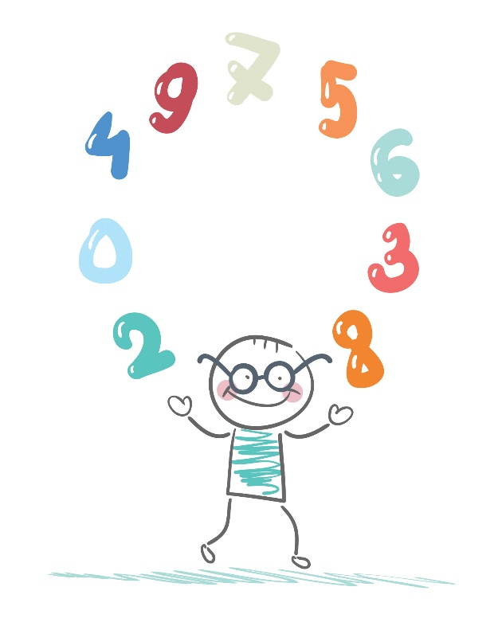
Place Value

Year 1: Place Value

Place Value | Count to and across 100, forwards and backwards, beginning with 0 or 1, or from any given number. Count, read and write numbers to 100 in numerals.
 | Count in multiples of twos, fives and tens.
 | Given a number, identify one more and one less.
 | Identify and represent numbers using objects and pictorial representations including the number line, and use the language of: equal to, more than, less than (fewer), most, least.
 | Read and write numbers from 1 to 20 in numerals and words.

In a family there is a mum, a grandad, a baby and an older brother. One is 60 years old, one is 35 years old, one is 1 year old and one is 5 years old. Show how old each person is.
Mum |  | Grandad
Baby |  | Older brother

In a race Emma finished before Rachel; Rachel finished before Tanya and Rhaisa. Tanya was last. | 5 boys line up in class. James is at the front; Hamid is next; then come Robert, Ali and Fred.
Who finished second? | Who is second in the line?
Who finished first? | Who is last in the line?

Look at the table below. Can you fill in the missing numbers?

1 | 2 | 3 | 4 | 5 | 6 | 7 | 8 | 9 | 10
11 | 12 | 13 | 14 |  | 16 | 17 | 18 | 19 | 20
21 | 22 | 23 | 24 | 25 | 26 | 27 |  | 29 | 30
31 | 32 | 33 | 34 | 35 | 36 | 37 | 38 | 39 | 40
41 | 42 | 43 | 44 | 45 | 46 | 47 | 48 | 49 | 50

Five girls took part in a dance competition. Maria scored 18 out of 20; Helen scored 15; Jade 19; Aysha 12 and Ellen 10. Who scored the most? | In a race, Ellie finished after Henry; Henry finished before Seth and Rhaisa. Seth finished before Rhaisa. Ellie was last. Who finished first?
Who had the lowest score? | Who finished second?

What is wrong with these sequences of numbers? | What is wrong with these sequences of numbers?
6, 7, 9, 10 _____________________________________________  8, 11, 14, 20 __________________________________________________________________  25, 20, 10, 5 _____________________________________________ | 27, 25, 21, 19 _________________________________________  12, 17, 21, 26 _____________________________________________________________  25, 20, 10, 5  ________________________________________

Look at the number cards below. Using the cards make up two 2-digit numbers that are less than 10 apart. | Look at the number cards below. Using the cards make up two 2-digit numbers that are more than 10 apart.
9  8  5  3  4 | 9  8  5  3  4

Yes or no:
If I count forwards in 2s from 4, I will say 19. Yes or No?

If I count backwards in 5s from 27, I will say 12. Yes or No?

If I count forwards in 10s from 62, I will say 91. Yes or No?

If I count backwards in 5s from 47, I will say 13. Yes or No?

Finish these sequences. What comes next?
10 + 1 = 11  11 + 1 = 12  12 + 1 = 13  ---- + ---- = ------ | 20 + 5 = 25  25 + 5 = 30  30 + 5 = 35  ---- + ---- = ----- | 16 – 5 = 11  17 – 4 = 13  18 – 3 = 15  ----- – ----- = -------
12 + 2 = 14  13 + 3 = 16  14 + 4 = 18  -----+ ----- = ------ | 20 + 1 = 21  21 + 1 = 22  22 + 1 = 23  ---- + ---- = ------ | 18 – 5 = 13  17 – 4 = 13  16 – 3 = 13  ----- – ----- = -------

How close did they get?
4 children were given a maths problem where the answer was 10. Jane wrote 14 as her answer, Ahmed wrote 8; Jo wrote 13 and Selma wrote 15. Who was closest to the answer? | 4 children were given a maths problem where the answer was 13. Jane wrote 18 as her answer; Ahmed wrote 8; Jo wrote 10 and Selma wrote 11. Who was closest to the answer?

Addition & Subtraction

Year 1: Addition and Subtraction

Add and Subtract | Read, write and interpret mathematical statements involving addition (+), subtraction (-) and equals (=) signs.
 | Represent and use number bonds and related subtraction facts within 20.
 | Add and subtract one-digit and two-digit numbers to 20, including zero.
 | Solve one-step problems that involve addition and subtraction, using concrete objects and pictorial representations, and missing number problems such as 7 = - 9.

Helen went to play with Cybel. Helen had 10 stickers and she gave Cybel 4 of them. Cybel already had 4 stickers. Which of the two girls had most stickers to play with? | Take 10 away from 18, and then add 3 to your answer. How many have you now?
Harry had 17 football cards. He wanted to give some to his friend Hamid. After giving them to Hamid, Harry had 3 more than Hamid. How many did each boy have? | Lucy has been given 15 monster munchies for her birthday. She has three friends who have 17 monster munchies between them. Share them out equally between them. Explain your answer.

The big race
The children run from the to the passing the and the on the way.

The distance between the and the is 2 m.

The distance between the and the is 4 m.

The distance between the and the is 3 m.

Work out the following distances.

How far is it from the to the ?

How far is it from the to the ?

How far is it from the to the ?

Six children took part in a football competition. Maria scored 8 goals out of 10, Moshin scored 4 out of 10, James scored 5 out of 10; and Thomas scored 2 out of 10.
How many goals were scored altogether?
Who won the competition?

I have 3 dice (1 to 6). Show three ways I can lay out the dice so that the numbers on top add up to 15.
I have 4 dice (1 to 6). Show three ways I can lay out the dice so that the numbers on top add up to 20.

Going on Holiday
On our way to our holiday town we started at town A we passed towns B and C before arriving at our holiday town D.
The distance between A and B is 50 km.
The distance between B and C is 20 km.
The distance between C and D is 50 km.
Work out the following distances.
How far was the journey from A to D?:
What is the distance between B and D?:
What is the distance between A and C?:
What is the distance between D and B?:

What do you notice about the following?
18 - 3 = 15 and 19 – 5 = 14
18 -15 = 3 19 – 14 = 5
Make up two other examples similar to the ones above.

Make up number sentences using all three numbers. The first one has been done for you.
12, 15, 3 15 – 3 = 12

7, 9, 16

21, 6, 15

Make up a different number sentence using the same three numbers. The first one has been done for you.
18 – 3 = 15 18 – 15 = 3

20 – 6 = 14

25 - 15 = 5

What happens when you change the addition sign (+) to a minus sign (-). The first one has been done for you. Now you try.

16 + 6 = 22 22 – 6 = 16

30 + 6 = 36

39 + 5 = 44

Put a circle around all the calculations that have an answer of 8.
5 + 3 15 – 7 23 + 3 12 - 5 12 – 4

12 + 3 5 +1 + 3 4 + 2 + 2 19 – 11 17 - 9

Put a circle around all the calculations that have an answer of 9.
6 + 3 16 – 7 23 + 13 22 - 15 13 – 4

12 + 13 7 +1 + 3 4 + 3 + 2 21 – 11 19 - 10

Put a circle around all the calculations that have an answer of 6.
6 + 3 16 – 10 23 + 13 22 - 15 13 – 7

12 + 13 2 +1 + 3 4 + 3 + 2 21 – 15 19 - 10

Triangular Problems
Look at the triangle on the left hand side. What numbers are missing from the triangle on the right hand side?
6  11 9  3  5  8 | 12 14  10

Dice time
I have 2 dice (numbered 1 to 6). Show two ways I can throw them so that the dice add up to 6.
I have 3 dice (numbered 1 to 6). Show two ways I can throw them so that the dice add up to 10.

Multiplication & Division

Year 1: Multiplication and Division

Multi | Solve one-step problems involving multiplication and division, by calculating the answer using concrete objects, pictorial representations and arrays with the support of the teacher.

There are a number of trees in the school grounds. Each tree drops 5 leaves each day. How many trees are there if we find 25 leaves on the ground each day?
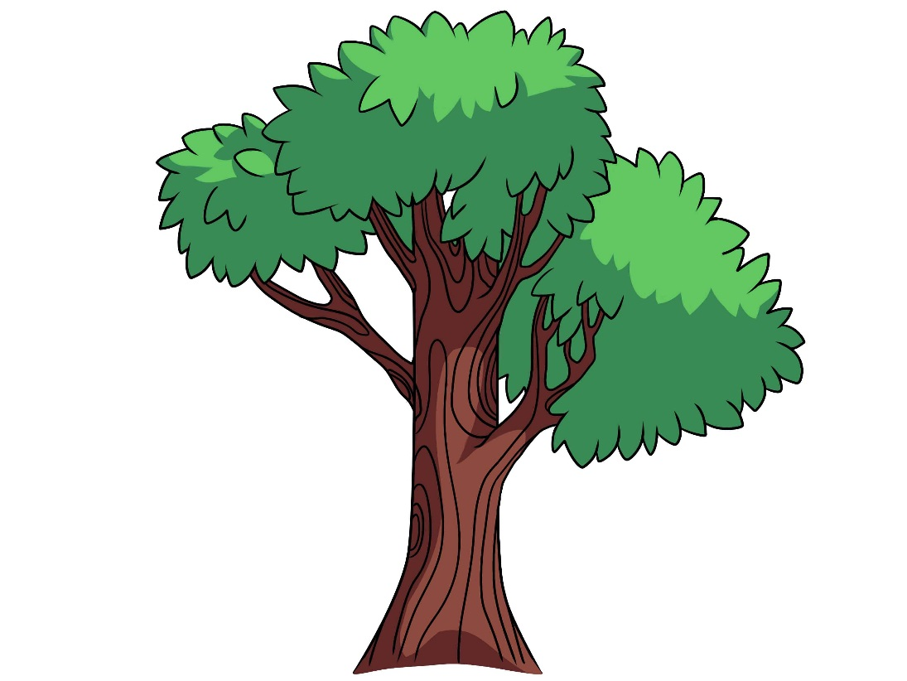

The school had a Christmas party. Everyone had to pay 5p to go to the party. They collected 60p altogether. How many children came to the party?

With my 50p pocket money I bought chocolate bars for 5p each. I have 20p left. How many chocolate bars did I buy?

4 girls share out red and green apples. Each has 2 red and 3 green apples. How many apples were there to start with?

3 children, Jake, India and Tom, share out chocolate and raspberry milk shakes. Jake only likes chocolate milk shakes. They all end up with 4 milk shakes each. India and Tom have the same amount of raspberry and chocolate milk shakes. How many chocolate milk shakes are there altogether?

Each of 3 girls was given 5 pencils each. How many pencils were there altogether?
Each set of 5 pencils was made up of 2 red; 1 yellow; 1 blue and 1 green. How many red pencils did the 3 girls have altogether?
5 girls each have a set of 5 pencils made up of 2 red; 1 yellow; 1 blue and 1 green. How many red and blue pencils do the 5 girls have altogether?

Fractions

Fractions | Recognise, find and name a half as one of two equal parts of an object, shape or quantity.
 | Recognise, find and name a quarter as one of four equal parts of an object, shape or quantity.

Harry went to play with Ahmed. Ahmed had 10 cars and he gave Harry half of them. Harry already had 2 cars. How many cars did Harry have to play with?

A football match lasted 60 minutes, how long did each half last?

A football match has 2 halves lasting 30 minutes each half. They also have 10 minutes between the 2 halves, how long does the match take from start to finish?

In a netball match, each half of the game lasted for 15 minutes and there was a 5 minute break between the two halves. How long was it between the beginning and the end of the match?

Yes or no.
If 3 children share 6 apples between them. Then they will all have 1 apple each.
Yes / No

If 4 children each have a quarter of a cake. Then there will be no cake left.
Yes / No

Can 3 children have half a packet of sweets?
Yes / No

If I give 3 children a quarter of all the sweets then there will be none left.
Yes / No

Sam and Ellen were given a bowl of smarties. There were 4 colours altogether. Half of all the smarties were red, 5 were yellow, 2 were blue and 3 were green.
How many smarties were there altogether?

10 children on a holiday camp went for breakfast. Half the group chose rice crispies; 2 chose corn flakes and the others chose Weetabix. How many chose to have Weetabix for breakfast?

A bowl of fruit on a table contained apples, pears, oranges and bananas.
One half of all the fruit in the bowl were apples. There were 2 pears; 3 oranges and 5 bananas. How many pieces of fruit were there altogether?

Measures

Measures | Compare, describe & solve practical problems for: lengths/heights (short/tall, half/ double ); mass/weight (heavier/lighter); capacity/volume (full/empty, more/less); time (quicker/slower/later)
 | Measure and begin to record the following: lengths/heights; mass/weight; capacity/volume; time (hours, minutes, and seconds).
 | Recognise and know the value of different denominations of coins and notes.
 | Sequence events in chronological order using language such as: before and after, next, first, today, yesterday, tomorrow, morning, afternoon and evening.
 | Recognise and use language relating to dates, including days of the week, weeks, months and years.
 | Tell the time to the hour and half past the hour and draw the hands on a clock face to show these times.

Write these in the order you would do them during the day.
- Get up in the morning
- Go to bed at night
- Have lunch
- Go to school
(Only use the words in bold)
1.
2.
3.
4.

Put the correct times on these clock faces.
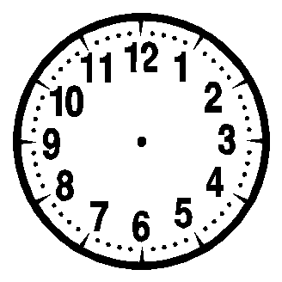
I go to bed at | I have lunch at

Write these in the order you would do them during the day.
- Have breakfast
- Have a bedtime story
- Eat your lunch
- Go home from school

(Only use the words in bold)
1.
2.
3.
4.

Put the correct times on these clock faces.

I get up in the morning at | I go to bed at

Which of these two weighs the most? Explain your answer.
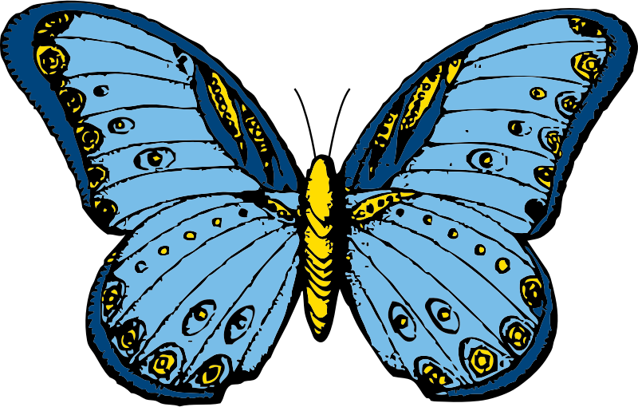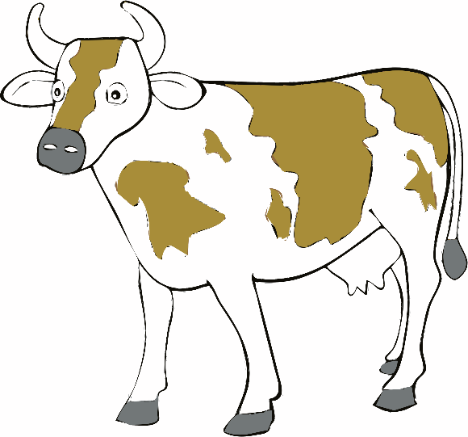

Butterfly Cow

Which of these two is the longer? Explain your answer.
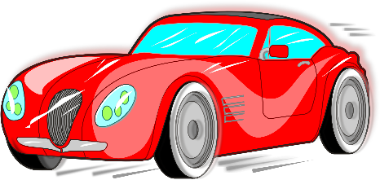

Bus Car

Paying bills
Show me two ways of paying £1.50.

Show me two ways of paying £2.75.

Sorting my coins
Ella has 2 different silver coins.
What is the smallest amount she can have? | What is the largest amount she can have?

Geometry

Geometry | Recognise and name common 2-D shapes (e.g. rectangles, circles and triangles) and 3-D shapes (e.g. cuboids (including cubes), pyramids and spheres).
 | Describe position, directions and movements, including whole, half, quarter and three-quarter turns.

What are the next 2 shapes in this sequence?

Make a robot using at least 1 circle, 1 square, 1 triangle and 1 rectangle.
The picture must include one of each shape.

What are the next 2 shapes in this sequence?

What are the next 2 shapes in this sequence?

Make a car using at least 2 circles, 1 square, 1 triangle and 1 rectangle.
The picture must include one of each shape.

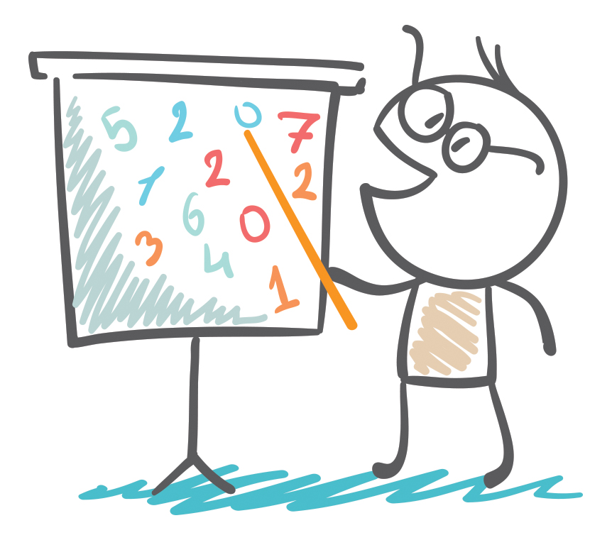
MASTERY IN MATHEMATICS
Year 2

YEAR 2 EXPECTATIONS

Year 2 Expectations
 | PV | - Read and write numbers to at least 100 in numerals and words
 | PV | - Count in steps of 2, 3 and 5 from 0 forwards and backwards
 | PV | - Recognise place value of each digit in 2-digit numbers
 | PV | - Compare and order numbers from 0 to 100 using the >; <; and = signs
 | AS | - Recall and use addition and subtraction facts to 20 fluently, and derive and use related facts up to 100
 | AS | - Add and subtract: two 1-digit; 2-digit and a 1 digit; 2-digit and 10s; two 2-digit and three 1-digit numbers
 | AS | - Solve problems with addition and subtraction
 | AS/ MD | - Understand commutativity in relation to addition, subtraction, multiplication and division
 | MD | - Recall and use multiplication and division facts for the 2, 5 and 10x multiplication tables
 | F | - Name the fractions 1/3 ; ¼ ; ½ and ¾ and find fractional values of shapes; lengths and numbers
 | M | - Choose and use appropriate standard units to estimate length/ height/ temperature and capacity
 | M | - Tell and write the time to 5 minute intervals
 | M | - Recognise and use the symbols £ and p when solving problems involving addition and subtraction of money
 | G | - Describe the properties of 2D and 3D shapes to include: edges, vertices and faces
 | S | - Interpret and construct pictograms, tally charts, block diagrams and simple tables

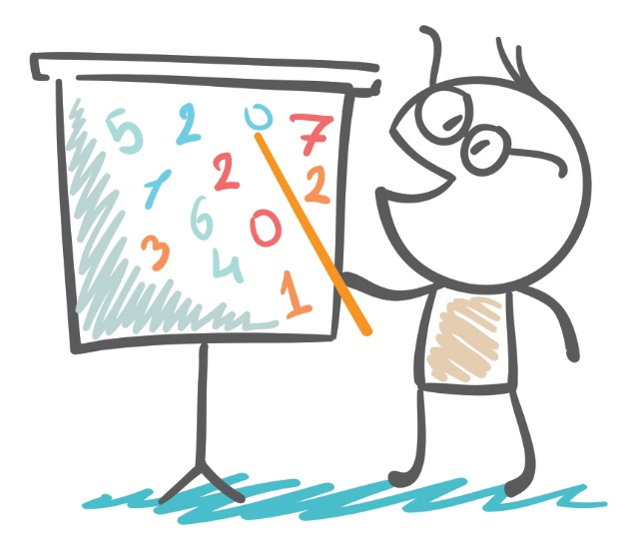
Place Value
Year 2: Place Value

Place Value | Count in steps of 2, 3, and 5 from 0, and in tens from any number, forward or backward.
 | Recognise the place value of each digit in a two-digit number (tens, ones).
 | Identify, represent and estimate numbers using different representations, including the number line.
 | Compare and order numbers from 0 up to 100; use <, > and = signs.
 | Read and write numbers to at least 100 in numerals and in words.

Here are the results of the Europe singing contest.
Country | Score
Great Britain | 88
Spain | 79
Germany | 91
France | 95
Turkey | 93

Who finished 1st? _______________________

Who finished 3rd? ________________________

Who finished 5th? ________________________

In a street all the odd numbers are on one side and the even numbers on the other. If the numbers on one side start with 1 what is the number of the 3rd house along? | In a street all the odd numbers are on one side and the even numbers on the other. If the numbers on one side start with 2 what is the number of the 4th house along?

Class 2 did a survey of the different types of trees in the local wood. Here are their results.
Tree | Number Found
Oak | 8
Chestnut | 5
Birch | 11
Cedar | 43
Sycamore | 17

Which type of tree was seen most? ________________
Which type of tree was seen least? ________________
How many trees altogether? _____________________

In a family there is mum (30), dad (32), great grandad (70), Uncle Tom (28), baby Ellen (1) and an older brother, Billy (7). On the chart below can you put them in order of age stating with the oldest? The first one is done for you.
Name | Age
Great Grandad | 70

Look at the number cards below. Using the cards make up two 2-digit numbers that are more than 20 apart. | Look at the number cards below. Using the cards make up two 2-digit numbers that are less than 20 apart.
9  8  5  3  4 | 9  8  5  3  4

In a family there is mum (28), dad (31), great grandad (66), Uncle Tom (19), baby Ellen (1) and an older brother, Billy (5). On the chart below can you put them in order of the age they will be in 10 years time? The first one is done for you.
Name | Age
Great Grandad | 76

6 children were given a maths problem where the answer was 61. Ariana wrote 55 as her answer; George wrote 43; Jemma wrote 68; Hamid wrote 72; Harry wrote 64 and Mustafa wrote 56. Who was closest to the answer? | 5 children were given a maths problem where the answer was 87. Harry wrote 85 as his answer; James wrote 73; Jen wrote 68; Ahmed wrote 92 and Harriet wrote 64. Who was closest to the answer?

Look at the following:
67 = 100 – 33
33 = 100 – 67
67 + 33 = 100
33 + 67 = 100
Make a similar pattern using the numbers 74, 26 and 100

Yes or no

I start with 4, and I count on in 3s, I will say 13.
Yes or No
I start with 7, and I count in 5s, I will say 19.
Yes or No
I start with 9, and I count in 10s, I will say 39.
Yes or No
I start with 8, and I count in 3s, I will say 31.
Yes or No

What is the value of 2 in the following numbers?
12
25
32
42
28

Create 2-digit numbers where the unit is one less than the tens. What is the largest possible number, and what is the smallest number, you can create?
Largest | Smallest
Create two 2-digit numbers that have a difference of 10 and the number in the ones is 7?

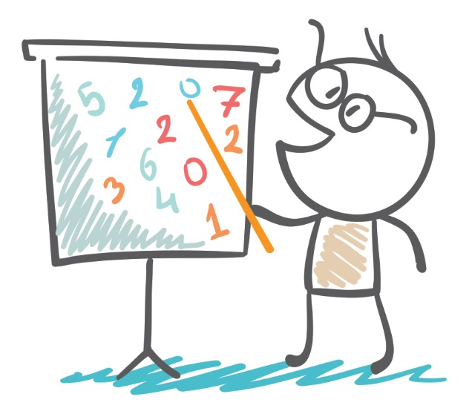
Add & Subtract

Year 2: Add and Subtract

Add and Subtract | Solve problems with addition and subtraction: using concrete objects and pictorial representations; applying their increasing knowledge of mental and written methods.
 | Recall and use addition and subtraction facts to 20 fluently, and derive and use related facts up to 100.
 | Add and subtract numbers using concrete objects, pictorial representations, and mentally, including: a 2-digit number and 1s or 10s; two 2-digit numbers; adding three 1-digit numbers.
 | Show that addition of two numbers can be done in any order (commutative) and subtraction of one number from another cannot.
 | Recognise and use the inverse relationship between addition and subtraction and use this to check calculations and missing number problems.

On a trip to the seaside I wanted to buy an ice cream for 15p; a bucket for 28p and a flag for 10p. I had 50p in my pocket. Did I have enough to buy all of these things?
What could I have bought with my 50p?

At a garden centre there are 3 sizes of pots for planting daffodils.
big | middle | small
I can plant 10 daffodils in the big pot, 8 daffodils in the middle size pot and 5 daffodils in the small pot.

If I buy 2 big pots, 3 middle size pots and 2 small pots, how many daffoldils can I plant altogether?

Helen is determined to be very healthy. Every day she exercises. After every press-up she has to rest for 1 minute; after every star jump she has to rest for ½ a minute and after every sit up she has to rest for 2 minutes. How much rest will she need after she does 5 press-ups, 10 star jumps and 7 sit ups?

On a visit to the zoo, I bought 2 toy monkeys for 10p each, 2 elephants for 8p each and a tiger for 14p. I had £1. Did I have enough to buy all these things? Explain your answer.
If I only wanted to buy elephants, how many could I have bought altogether with my £1?

Yes or no
73 + 40 = 113 Yes or No

98 – 18 = 70 Yes or No

46 + 77 = 123 Yes or No

92 – 67 = 35 Yes or No

Complete the following calculation.
+ + = 17

Write 4 number sentences involving + and – using the numbers 100, 67 and 33.

What digits could go into the boxes?
7 - 2 = 46

I have 4 dice (1 to 6). Show three ways I can lay out the dice so that the numbers on top add up to 22.
I have 6 dice (1 to 6). Show three ways I can lay out the dice so that the numbers on top add up to 26.

If you add any 3 numbers less than 10, the answer will always, never or sometimes be odd. Circle your answer.
always sometimes never

Look at the example on the left hand side below. Complete the problem on the right hand side, putting the correct numbers in the empty squares.
10  4  5  6  1  6  7 | 7  5  6

Look at the example on the left hand side below. Complete the problem on the right hand side, putting the correct numbers in the empty squares.
4  10  3  6  7  6  1 | 7  5  8

Multiply & Divide

Year 2: Multiply & Divide

Multiply & Divide | Recall and use multiplication and division facts for the 2, 5 and 10 multiplication tables, including recognising odd and even numbers.
 | Calculate mathematical statements for multiplication and division within the multiplication tables and write them using the multiplication (×), division (÷) and equals (=) signs.
 | Show that multiplication of two numbers can be done in any order (commutative) and division of one number by another cannot.
 | Solve problems involving multiplication and division, using materials, arrays, repeated addition, mental methods, and multiplication and division facts, including problems in contexts.

There are trees around the school grounds. Each tree produces the same number of apples. If 35 apples are collected from all the trees. How many trees could there be altogether? Tick all possible answers.
10
5
8
7

The school has a Christmas party. Everyone has to pay 5p to go to the party. How much money could have been collected? Tick all possible answers.
£1
58p
82p
75p

There are 6 areas for planting flowers around school. Each planter grows the same number of flowers. How many flowers could there be altogether? Tick all possible answers.
18
45
66
19

A class has an Easter bonnet parade. Everyone has to pay 5p to enter the parade. How much money could be collected? Tick all possible answers.
£1.20p
18p
60p
72p

At a paint shop there are 3 different sizes of paint pots.
big | middle | small
A big pot costs 20p each, a middle size pot costs 15p each and a small pot costs 10p each.

If I buy 2 big pots, 3 middle size pots and 2 small pots then how much money will I spend?

I have 24p in my purse in 2p and 1p coins. How many coins could I have altogether? Set out how many of each. Show your answer.

I have 35p in my purse in 5p and 10p coins. How many coins could I have altogether? Set out how many of each. Show your answer.

I have £2.50p in my purse in 50p and 20p coins. How many coins could I have altogether? Set out how many of each. Show your answer.

Write 4 number sentences to link the numbers:
4, 3 and 12.

5 children share their sweets, when they have shared them all out they are joined by another friend. Each of the five children give one of their sweets to their new friend. All 6 children now have the same number of sweets. How many sweets could there have been in the first place?

Fractions

Year 2: Fractions

Fractions | Recognise/find/name/write fractions ⅟₃, ⅟₄, 2/4, ᶟ∕₄ of a length, shape, set of objects or quantity.
 | Write simple fractions e.g. ⅟₂ of 6 = 3 and recognise the equivalence of 2/4 and 1/2.

Spot the mistake in this sequence.
7, 7½, 8, 8½, 9½, 10

___________________________________________

Write the next 2 in this sequence.
¼ of 8 = 2
¼ of 16 = 4
¼ of 32 = 8
___________________

____________________

Put these fractions in the right order (smallest first)
¼, ½, ⅛
___________________________________________

Yes or no
Half of 30cms is 60cms. Yes or No
¾ of 16cms is 12cms. Yes or No

John and Ahmed shared a packet of fruit spangles. There were 5 colours altogether. Half of all the sweets were red. 5 sweets were yellow, 2 were black, 3 were green and 6 were purple.
How many sweets were there altogether?

A café had different cereals in small packets. A quarter of all the cereals were corn-flakes. Six packets were Weetabix, 5 were rice crispies, 4 were honey snacks and 9 were coco-pops. How many packets of cereals were there altogether?

Measures

Year 2: Measures

Measures | Choose/use appropriate standardised units to estimate/measure length/height (m/cm); mass (kg/g); temp (°C); cap (litres/ml) to nearest unit, using rulers, scales, thermometers and measuring vessels.
 | Compare and order lengths, mass, volume/capacity and record the results using >, < and = .
 | Recognise and use symbols for pounds (£) and pence (p); combine amounts to make a particular value. Find different combinations of coins that equal the same amounts of money.
 | Solve simple problems in a practical context involving addition and subtraction of money of the same unit, including giving change.
 | Compare and sequence intervals of time. Know the number of minutes in an hour and the number of hours in a day.
 | Tell and write the time to five minutes, including quarter past/to the hour and draw the hands on a clock face to show these times.

TIME
A film finishes 2 hours after it starts. It finishes at 5.30. What time did it start?

Show the time on the clock faces:
Start of film.
End of film.

Start of Film End of Film

TIME
The time is 12.30. Rhian says there are 2 hours to wait before her favourite TV programme starts. What time does her favourite programme start?

TIME: True or False
Are these statements TRUE or FALSE?
It is two o’clock and it will be half past three in 1 and a half hours.
True or False?

It is four o’clock and it was half past one an hour and a half ago.
True or False?

It is 11 o’clock and it will be 1 o’clock in 2 hours’ time.
True or False?

LENGTH
Draw 2 lines whose length differs by 5cms.

LENGTH
Draw 2 lines whose length differs by 7cms.

LENGTH
Draw one line that is 5cms long and another that is 6cms longer.

MONEY
Show 2 ways in which you can make 56p using only 20p, 10p and 1p coins.

MONEY
Show 3 ways in which you can make 67p using only 50p, 20p, 10p and 1p coins.

MONEY
Show 3 ways in which you can make £1.50p using only 50p, 20p, 10p and 5p coins.

Geometry

Year 2: Geometry

Geometry | Identify and describe the properties of 2D shapes, including the number of sides and symmetry in a vertical line.
 | Identify and describe the properties of 3D shapes, including the number of edges, vertices and faces.
 | Identify 2D shapes on the surface of 3D shapes, e.g. circle on a cylinder; a triangle on a pyramid.
 | Compare and sort common 2D and 3D shapes and everyday objects.
 | Order and arrange combinations of mathematical objects in patterns and sequences.
 | Use math vocab to describe position, direction and movement including movement in a straight line and distinguishing rotation as a turn and in terms of right angles for ⅟₄, ⅟₂, and ᶟ∕₄ turns (clock/anti-clockwise).

Draw a building that includes at least 4 squares, 2 rectangles, 2 triangles and at least 1 circle.

Draw a car, van or train that includes at least 2 squares, 2 rectangles, a triangle and at least 2 circles.

Draw a car, van or train that includes at least 1 square, 3 rectangles, 2 triangles and at least 4 circles.

Think of a rectangle where one of its sides is twice the length of the other. What could the measurements of the sides be?

Always, sometimes, never?
Is it always, sometimes or never true that when you fold a square in half you get a rectangle? Circle your answer.
always sometimes never

Always, sometimes, never?
Is it always, sometimes or never true that when you fold a rectangle in half you will get a square? Circle your answer.
always sometimes never

A shape has straight sides and all its sides are the same length. Name 2 possible 2D shapes that fit this description.

Position
If I face forwards and turn three quarter turns clockwise then a quarter turn anti-clockwise describe my finishing position.

Position
If I face forwards and turn one quarter turn clockwise then three quarter turn anti-clockwise describe my finishing position.

Statistics

Year 2: Statistics

Stats | Interpret and construct simple pictograms, tally charts, block diagrams and simple tables.
 | Ask and answer simple questions by counting the number of objects in each category and sorting the categories by quantity; ask and answer questions about totalling and comparing categorical data.

In a class children are asked to vote for their favourite subject. 10 voted for PE, 6 voted for maths, 5 for history, 4 for art, 2 for geography and 1 for reading. Use the table below to show how everyone voted, putting the most popular subject first (the first has been done for you).
Subject | Votes
PE | 10

Graphs and Charts:
What would be a good survey to carry out in your class so as to show similarities and differences in your class’s views?
Think of 2 ideas.

Tally
Throw 2 dice 20 times and make a tally of the sum of the throws. | Throw 2 dice 20 times and make a tally of the difference between the numbers for each throw.
2  3  4  5  6  7  8  9  10  11  12 | 0  1  2  3  4  5

