


© Focus Education (UK) Ltd 2015

All rights reserved
Reproduction, storage, adaptation or translation, in any form or by any means, of this publication is prohibited without the prior written permission of the publisher. Excerpts may be reproduced for the purpose of research, private study, criticism or review, or by educational institutions solely for educational purposes, without permission, providing full acknowledgement is given.
This publication should only be used be the purchasing organisation or individual. Focus Education does not grant permission for the purchaser to distribute the content of this publication outside their organisation, this includes placing the whole document or parts on social media or internet sites.

First Published in the UK in 2015 by Focus Education (UK) Ltd

Focus Education (UK) Ltd
Publishing
Talking Point Conference & Exhibition Centre
Huddersfield Road
Scouthead
Saddleworth
OL4 4AG

Focus Education (UK) Ltd Reg. No 4507968

ISBN 978-1-909038-74-5
Companies, institutions and other organisations wishing to make bulk purchases of books published by Focus Education should contact their local bookstore or Focus Education direct:
Customer Services, Focus Education, Talking Point Conference & Exhibition Centre,
Huddersfield Road, Scouthead, Saddleworth, OL4 4AG
Tel 01457 821818 Fax 01457 878205
www.focus-education.co.uk
customerservice@focus-education.co.uk
Printed in Great Britain by Focus Education UK Ltd, Scouthead
ABOUT THE AUTHOR

Clive Davies, OBE is one of the founding Directors of Focus working with school both nationally and internationally. He draws on a vast experience, including work as a headteacher, Ofsted inspector, trainer and consultant.
Clive has a wealth of experience working with schools to analyse their current position and supporting leaders to construct purposeful and fit-for-purpose self-evaluation systems which impact on pupil outcomes. Over recent years, Clive has been focusing particularly on the development of an approach to leading and delivering the curriculum which ensures a high degree of engagement for children. This approach to the curriculum is being used in schools across England. He is one of the innovators for the learning challenge curriculum which has gained national acclaim for its success. Clive works in all areas of school improvement and works from early years through the secondary phase.
As a headteacher, Clive’s school gained a National Curriculum Award and featured in the TES as one of three schools recognised for its quality practice. Clive has a national and international reputation as an authoritative speaker. He has recently worked in the Middle East, Europe and Japan.
Clive has written a wide range of publications which have become known for their straight forward and useful style; helping school leaders focus on what is most important to making a difference, including the best-selling ‘Raising Standards by Setting Targets’. Some of Clive’s most recent and bestselling publications are:

- Making Good Lessons Outstanding
- Maths Learning Challenge Curriculum: Pre and Post Learning Challenges
- Talk for Success
- Science Learning Challenge Curriculum
- History & Geography Learning Challenge Curriculum
- Leading the EYFS (co-authored with Sarah Quinn)
- Assessing Science and Non-Core Subjects: In the new National Curriculum (Years 1 to 6)
- Focus on Maths (co-authored with Helen Rowland)
- Assessing without Levels
- Empowering Learners: A Focus on Learning Behaviours
- Step up to the Challenge Series
- Making Book Scrutiny more Meaningful

Introduction: Mastery in Mathematics

This booklet aims to provide teachers in Year 3 & 4 with ideas to help develop pupils’ mastery skills in mathematics. They are intended to be used alongside units of mathematics that are on-going in the classroom. For example, when pupils are being taught ‘Place Value’ teachers could choose an appropriate question to help deepen pupils’ understanding of that aspect of mathematics.  Importantly, these should be used with all pupils not just the most able.  They should also be interwoven into everyday mathematics lessons not just left until the end of each unit.  The examples have been split into different areas so as to help teachers with their planning. Naturally, some examples cover more than one area.  The questions are simply exemplars and teachers are encouraged to develop questions that are similar to the ones outlined in this booklet. The questions take full account of the need for pupils to ‘think harder’ and to use their reasoning skills.
  Possible Characteristics of Mastery
  Independence | Can apply the skill or knowledge without referring to the teacher.
  Fluency | Can apply the skill or knowledge with a high level of confidence.
  Application | Can apply the skill or knowledge to a range of different contexts, including other areas of the curriculum.
  Consistency | Can use of their skills and understanding consistently.
  Synthesis | Can organise ideas, information, or experiences into new, more complex interpretations and relationships.
  Re-visit | Can return to this aspect of learning after a break and still feel confident that they can work on the skill or knowledge without difficulty.
  When considering deep learning opportunities teachers need to ensure that the activities are enhancing the characteristics outlined above.

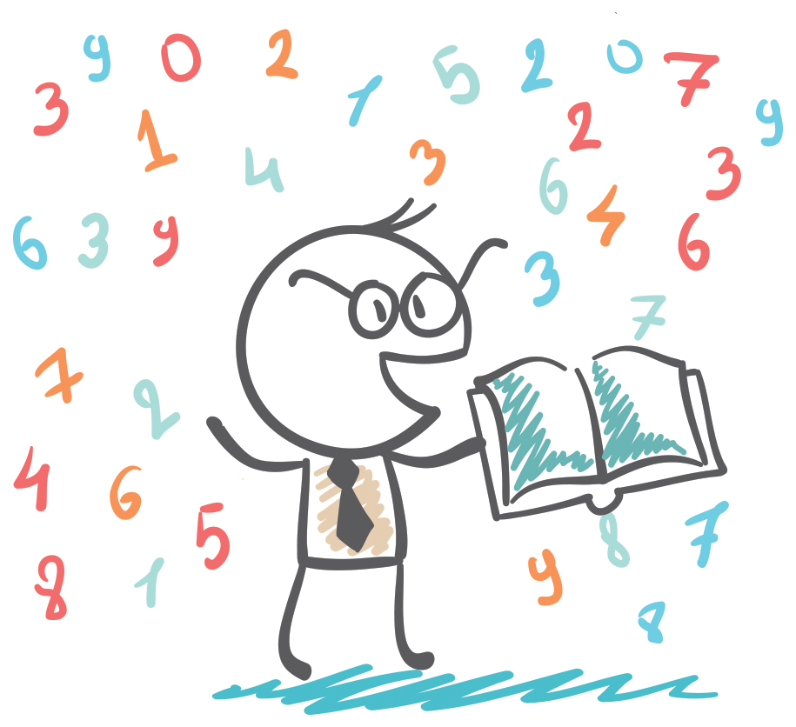
MASTERY IN MATHEMATICS
Year 3

YEAR 3 EXPECTATIONS

Year 3 Expectations
 | PV | - Compare and order numbers to 1000 and read and write numbers to 1000 in numerals and words
 | PV | - Count from 0 in multiples of 4, 8, 50 and 100
 | PV | - Recognise the value of each digit in a 3-digit number
 | AS | - Add and subtract mentally combinations of 1-digit and 2-digit numbers
 | AS | - Add and subtract numbers with up to 3-digits using formal written methods
 | AS | - Solve number problems using one and two step operation
 | MD | - Derive and recall multiplication facts for 3, 4 and 8x multiplication tables
 | MD | - Write and calculate mathematical statements for multiplication and division; including 2-digit number with a 1-digit number (from multiplication tables they know, ie, 2, 3, 4, 5, 8 and 10)
 | F | - Understand and count in tenths, and find the fractional value of a given set
 | F | - Add and subtract fractions with a common denominator
 | G | - Identify right angles; compare other angles to being greater or smaller than a right angle
 | G | - Identify horizontal and vertical lines and pairs of perpendicular and parallel lines
 | M | - Tell time to nearest minute and use specific vocabulary: seconds, am and pm
 | M | - Measure, compare, add and subtract using common metric measures
 | S | - Solve one-step and two step problems using information presented in scaled bar charts, pictograms and tables

Place Value
Year 3: Place Value

Place Value | Count from 0 in multiples of 4, 8, 50 and 100. Find 10 or 100 more or less than a given number.
Place Value | Recognise the place value of each digit in a three-digit number (hundreds, tens, ones).
Place Value | Compare and order numbers up to 1000. Read and write numbers up to 1000 in numerals and in words.
Place Value | Identify, represent and estimate numbers using different representations.
Place Value | Solve number problems and practical problems involving these ideas.

Creating 3-digit numbers
Make up a 3-digit number where the sum of the numbers is 9, e.g. 333 or 450.
What is the largest number you can make?

What is the second largest number you can make?

True or false
Circle either True or False against each number statement
25 is one half of 50 True or False

75 is a multiple of 5 True or False

75 is the same as 24 times 3 True or False

105 is half of 220 True or False

Creating 3-digit numbers
Make up a 3-digit number where the sum of the numbers is 5, e.g., 122 or 212.
What is the largest number you can make?

What is the second largest number you can make?

Spot the mistake

What is wrong with these sequences of numbers?

50, 100, 115, 200

75, 100, 125, 150, 165, 200

Thinking scientifically
In a science lesson children measure their height and weight. Here is a chart of their results.
Name | Weight  (kg) | Height  (cm)
Luke | 52 | 98
Kaymer | 58 | 102
Grace | 47 | 89
George | 71 | 110
Kane | 65 | 105

Who is the heaviest person?
Who is the shortest person?
Luke grows 10cm. How tall is he now?

Chasing Shadows
At different times of the day pupils measured the length of their shadows. The table shows the outcomes:
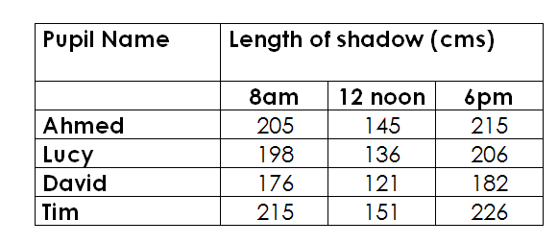

Say which person’s shadow was the longest and when.

Work out who the tallest person is.

At what time of day are shadows longest?

What is the difference between the shadow of the tallest person at 6pm and the shortest person at 12 noon?

Creating 3-digit numbers
Look at the number cards below. Using the cards make up two 3-digit numbers that are more than 100 apart. | Look at the number cards below. Using the cards make up two 3-digit numbers that are less than 100 apart.
9  8  5  3  4 | 9  8  5  3  4

Look at the number cards below. Using the cards make up two 3-digit numbers that are more than 50 apart. | Look at the number cards below. Using the cards make up two 3-digit numbers that are less than 50 apart.
9  8  5  3  4 | 9  8  5  3  4

What’s the answer?
6 children were given a maths problem where the answer was 198. Ariana put down 155 as her answer; George put down 183; Jemma put down 208; Hamid put down 217; Harry put down 164 and Mustafa put down 198. Who was closest to the answer and who was furthest away? | 5 children were given a maths problem where the answer was 487. Harry put down 385 as his answer; James put down 473; Jen put down 618; Ahmed put down 592 and Harriet put down 464. Who was closest to the answer and who was furthest away?

More 3-digit numbers
Create 3-digit numbers where the unit is one less than the tens and the tens is one less than the hundreds. What are the largest and smallest possible numbers you can create?
Largest | Smallest
Create two 3-digit numbers that have a difference of more than 10 with the ones number being 7 and the hundreds number being 6?

Add & Subtract
Year 3: Add & Subtract
Add and Subtract | Add and subtract numbers mentally, including: a 3-digit no and 1s, 10s, 100s.
Add and Subtract | Add and subtract numbers with up to 3 digits, using formal written methods of columnar addition and subtraction.
Add and Subtract | Estimate the answer to a calculation and use inverse operations to check answers.
Add and Subtract | Solve problems, including missing no problems, using number facts, place value, and more complex addition/subtraction.

Making an estimate

Which of these number sentences have the answer that is between 50 and 60
174 - 119
333 – 276
932 - 871

Always, sometimes, never
Is it always, sometimes or never true that if you subtract a multiple of 10 from any number the units digit of that number stays the same? Circle your answer
always sometimes never

True or false
Are these number sentences true or false? Give your reasons.

597 + 7 = 614
804 – 70 = 744
768 + 140 = 908

Hard or easy?
Explain why you think the hard questions are hard?

323 + 10 =
393 + 10 =
454 - 100 =
954 - 120 =

Missing digits

___ + ___ + ___ = 201

Each missing digit is either a 9 or a 1. Write in the missing digits. Can you find different ways of doing this?

Making an estimate

Which of these number sentences have the answer that is between 50 and 60
194 - 149
433 – 376
732 – 571

Always, sometimes, never

Is it always, sometimes or never true that if you subtract a multiple of 10 from any number the units digit of that number stays the same?
always sometimes never

Is it always, sometimes or never true that when you add two numbers together you will get an even number?

always sometimes never

Toy shop
Here are the prices of items in a toy shop. You have £15 to spend. Write below which toys you can afford to buy whilst leaving yourself no more than £2 in change.
Model car | doll | Train set | puzzle | jigsaw
£2 | £4 | £5 | £2 | £1
Magic set | Ball | Skipping rope | Cricket set | Goalposts
£6 | £2 | £2 | £10 | £11
Which toys have you bought? (Don’t forget they can’t total more than £15.)
You have 3 friends to buy for and your parents say you cannot spend more than £20. Make a list of your purchases.
Friend A ____________________________________

Friend B ____________________________________

Friend C ____________________________________

The dice game
I have 8 dice (1 to 6). Show three ways I can lay out the dice so that numbers on top add up to 32.
I have 10 dice (1 to 6). Show three ways I can lay out the dice so that numbers on top add up to 43.
The two opposite sides of a dice always add up to 7. If the top numbers of 3 dice are 4, 2 and 5, how much will the bottom numbers add up to?

Cafe
At the café, next to school, you can buy the following:
Drink | Snack | Lunch
Tea 40p  Coke 25p  Coffee 40p  Milk 20p  Water 10p  Orange Juice 15p | Crisps 35p  Biscuits 20p  Sweets 25p  Apple 15p | Burger 75p  Sausage Roll 45p  Chips 35p  Bacon Roll 55p
You have £1 to spend. Choose 1 item from each group to buy. List them below and then work out how much they cost you altogether. How much change you will have from £1?
Drink | Snack | Lunch

Total Cost Change

Relay run
Four runners each ran 100m in a relay. The first runner took 16 seconds; the second 15 seconds; the third 18 seconds and the last runner took 14 seconds. How long did it take for the runners to complete the relay?
The four runners completed the relay in 78 seconds. The fastest runner ran her leg twice as fast as the slowest runner and the other two ran their leg in the same time. How fast did each runner run? Give one possible solution.

The 25 Dice trick
25 dice are placed together as below. All dice have numbers 1 to 6.
Set out the dice in any way you want in another 5 x 5 pattern so that the numbers facing upwards add up to 125.
Set out the dice in any way you want in another 5 x 5 pattern so that the numbers facing upwards add up to 105.
Set out the dice in any way you want in a 6 x 6 pattern so that the numbers facing upwards add up to 125.
Set out the dice in any way you want in a 4 x 4 pattern so that the numbers facing upwards add up to 56.

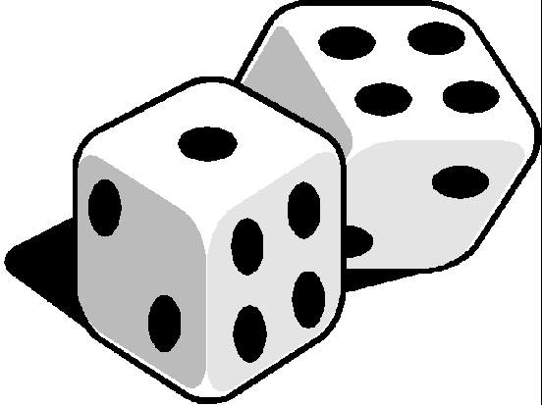
4 | 4 | 4 | 3 | 3
4 | 4 | 3 | 3 | 3
4 | 3 | 3 | 3 | 3
3 | 3 | 3 | 3 | 3
3 | 3 | 3 | 3 | 4

Triangle fun
Look at the example on the left hand side below. Complete the problem on the right hand side, putting the correct numbers in the empty squares.
10  8  20  12  2  6  14 | 30  16  26

More triangle fun
Look at the example on the left hand side below. Complete the problem on the right hand side, putting the correct numbers in the empty squares.
6  8  4  12  2  6  8 | 3  10  7

Dart board problem
10  15  45  40  20  30  25  35 | A special dart board has 8 numbers from 10 to 45 going up in 5s.  If the dart hits a segment in the blue area the number doubles so the highest possible number could be 90.  How many ways could the 3 darts be placed to score exactly 200? Write out all possibly combinations.
10  15  45  40  20  30  25  35 | How many ways can you score 150?  Set out your combinations.
10  15  45  40  20  30  25  35 | How many ways could you score 100?  Set out your combinations

Multiply & Divide
Year 3: Multiply & Divide

Multiply & Divide | Recall and use multiplication and division facts for the 3, 4 and 8 multiplication tables.
Multiply & Divide | Write and calculate math statements for x and ÷ using the tables they know, including 2-digit numbers times 1-digit numbers, using mental and formal written methods.
Multiply & Divide | Solve problems and missing number problems, involving x and ÷, including integer scaling problems and correspondence problems in which n objects are connected to m objects.

How close can you get?

X =

Using the digits 2, 3 and 4 in the calculation above. How close can you get to 100?

What is the largest product?
What is the smallest product?
X =

Using the digits 5, 6 and 7 in the calculation above. How close can you get to 200?

What is the largest product?
What is the smallest product?

Use the inverse

Use the inverse to check if the following calculations are correct.

23 x 4 = 82
117 ÷ 9 = 14

Size of an answer

Will the answer to the following calculations be greater or less than 80?

23 x 3=
32 x 3 =
42 x 3 =
36 x 2=

Checking cost
A class of 30 has planned a visit to a museum. If everyone pays the same to enter, how much money could be collected?
Put a tick or a cross against the possible answers.
£30
£25
£60
£75
£29

A family of 4 decided to go to see the latest film about a Stone Age boy. Tickets for the adults cost twice as much as the tickets for the children. How much might the family have spent altogether?
£15
£34
£60
£23
£29

In a Mediterranean hotel a breakfast costs £5. The bill for the room and breakfasts, at the end of 7 days, costs £315. How much does the room cost each day?

Dinosaur park
A group of adults and children decided to visit the dinosaur park. The adults paid twice as much as the children. The group paid £150. How many adults and children could have been in the group? Give two different answers.
Holiday
A family of 2 adults and 4 children go on holiday. The air tickets cost £105 for each adult and £72 for each child. The hotel bill is £250 for all of them. How much does the family spend altogether?

Multiple triangles
Look at the example on the left hand side below. Complete the problem on the right hand side, putting the correct numbers in the empty squares.
10  5  20  6  4  2  8 | 30  50  15

Dice multiplication and division
 | I threw 2 dice. The numbers when multiplied made 24. What were the numbers? | I threw 2 dice. The numbers when multiplied made 12. How many pairs of numbers could there have been? What are they?
 | I threw 2 dice. The numbers when divided made 2. What were the possible combination of the dice numbers? | I threw 2 dice. The numbers when divided made 3. What were the possible combination of the dice numbers?

Fractions
Year 3: Fractions
Fractions | Count up and down in tenths; recognise that tenths arise from dividing an object into 10 equal parts and in dividing one-digit numbers or quantities by 10.
Fractions | Recognise, find and write fractions of a discrete set of objects: unit fractions and non-unit fractions with small denominators.
Fractions | Recognise and use fractions as numbers: unit fractions and non-unit fractions with small denominators.
Fractions | Recognise and show, using diagrams, equivalent fractions with small denominators.
Fractions | Add and sub fractions with the same denominator within one whole (e.g. ⁵∕₇ + ⅟₇ = ⁶∕₇).
Fractions | Compare and order unit fractions, and fractions with the same denominators.

Ordering

Put these fractions in the correct order, starting with the smallest.

4/8 3/4 1/4

What do you notice?
Continue the pattern
1/10 + 9/10 = 1
2/10 + 8/10 = 1
3/10 + 7/10 = 1

Make up a similar pattern for eighths.

Gardening
A gardener has been very busy planting seeds. Work out how many of these become full grown plants by looking at the table below.
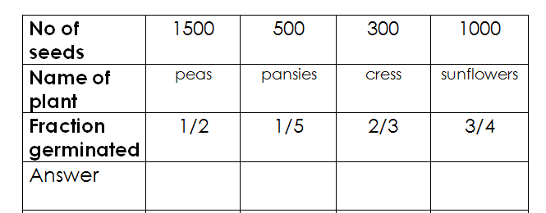

Bowl of Fruit
One eighth of a bowl of fruit was made up of bananas. A quarter was made up of pears and a half was made up of apples. | One tenth of a bowl of fruit was made up of kiwi fruit. Three tenths was made up of pears and a half was made up of apples.
If there were no more than 30 pieces of fruit altogether, how many bananas, pears and apples could there have been in the fruit bowl? | If there were no more than 50 pieces of fruit altogether, how many kiwi fruit, pears and apples could there have been in the fruit bowl?
Garden centre
In a garden centre, the owner was working out how well his plants were selling. Work out how many of each plant he had sold.
Name of plant | Rose | Conifer bush | Camellia | Honeysuckle
Number of plants | 60 | 60 | 30 | 40
Fraction sold | 2/3 | 1/4 | 1/2 | 3/5
Answer

In a forest
In a forest, the warden had to cut down a number of trees so that new ones could be planted. Work out how many of each type of tree is cut down.
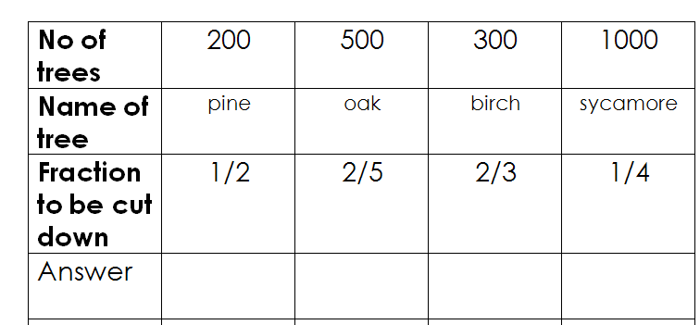

On a Farm
On a farm there were sheep; chickens; cows and horses. 1/2 of the animals were sheep, 1/3 were chickens, 1/10 were cows and the rest were horses.

If the farm had more than 200 animals but less than 230, how many sheep, chickens, cows and horses were there on the farm?

If there were more than 250 animals altogether but less than 280, how many sheep, chickens, cows and horses were there?

Measures
Year 3: Measures
Measures | Measure, compare, add and subtract: lengths (m/cm/mm); mass (kg/g); volume/capacity (l/ml).
Measures | Measure the perimeter of simple 2-D shapes.
Measures | Add and subtract amounts of money to give change, using both £ and p in practical contexts.
Measures | Tell/write the time from an analogue clock, including Roman numerals from I to XII, and 12-hr/24-hr clocks.
Measures | Estimate and read time with increasing accuracy, to nearest min; record/compare time in seconds, minutes, hrs. Use vocabulary such as o’clock, am/pm, morning, afternoon, noon and midnight.
Measures | Know the number of seconds in a minute and the number of days in each month, year and leap year.

Ordering

Put these measurements in order starting with the largest.

Half a litre  Quarter of a litre  300 ml | 500 metres  1Km  5000 cms

Position the symbols

Place the correct symbol between the measurements > or <

306 cm Half a metre
930 ml 1 litre

Explain your thinking

Undoing

A television programme lasting 45 minutes finished at 5.20. At what time did it start?

Draw a clock to show the start and finish times.

Explain thinking

Salha says that 100 minutes is the same as 1 hour.
Is Salha right? Explain your answer.

Write more statements

(You may choose to consider this practically)
If there are 630ml of water in a jug, how much water do you need to add to make a litre of water?
What if there was 450 ml to start with? Make up some more questions like this

Perimeter

The side of a square is equivalent to a whole number (in cms). Which of the following measurements could represent its perimeter?
8cm 18cm 24cm 25cm

Possibilities

I bought a book which cost between £9 and £10 and I paid with a ten pound note.
My change was between 50p and £1 and was all in silver coins. What price could I have paid?

The answer is…

25 minutes  What is the question? | 45 minutes  What is the question?

What do you notice?

1 minute = 60 seconds 2 minutes = 120 seconds

Continue the pattern. Write down some more time facts like these.

Time and time again
How many hours are there in 2 days? | How many hours are there in 1 week?
It is now half past eight.  Helen has to be home by 11 o’clock and she is watching a film at her friend’s house which lasts 2 hours. It takes 10 minutes to walk home.  Has she enough time to watch all the film? | It is now one o’clock  Paul has to be home by half past three.  He is playing football for his team. The game lasts for 1 and a half hours. It takes half an hour to have a shower after the game and 15 minutes to get home.  Has he enough time to get home on time?

Geometry
Year 3: Geometry
Geometry | Draw 2-D shapes and make 3-D shapes using modelling materials; recognise 3-D shapes in different orientations and describe them.
Geometry | Recognise that angles are a property of shape or a description of a turn.
Geometry | Identify right angles, recognise that 2 right angles make a half-turn, 3 make three quarters of a turn and 4 a complete turn. Identify whether angles are greater than or less than a right angle.
Geometry | Identify horizontal and vertical lines and pairs of perpendicular and parallel lines.

What’s the same, what’s different?

What is the same and different about these three 2-D shapes?

Visualising 3-D shapes

I am thinking of a 3-dimensional shape which has faces that are triangles and squares.
What could my shape be?

One face of a 3-D shape looks like this.

What could it be?
Are there any other possibilities?

Always, sometimes, never

Is it always, sometimes or never that all sides of a hexagon are the same length.

always sometimes never

Perpendicular or parallel

Which capital letters have perpendicular and / or parallel lines?

Working backwards

If I make the two opposite sides of a square 5 cm longer the new lengths of those sides are 27cm.
What was the length of the side of my original square?
What is the name and length of sides of my new shape?

Drawing horizontal or vertical lines
Below, draw a horizontal line that is 5cm long and a vertical line that is 3 cm long.

Overlapping squares
How many squares can you make by overlapping 3 squares of the same size?

Statistics

Year 3: Statistics
Stats | Interpret and present data using bar charts, pictograms and tables.
Stats | Solve one-step and two-step questions such as ‘How many more?’ and ‘How many fewer?’ using information presented in scaled bar charts, pictograms and tables.

Science Lessons
In a science lesson children are looking at muscles and skeletons. They try to find out how much weight they can lift from the floor to their tummies. Here is a chart of their results.
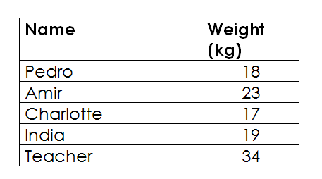
Who can lift the heaviest weight?

How much can India and Charlotte lift altogether?

Calculate the difference between the person who can lift the most and the person who can lift the least.

Television kids
Children in a class talk about how much television they watch each week. They decide to keep a record for 3 weeks and then put their information on this chart.
Pupil Name | Number of hours watched each week
 | Week 1 | Week 2 | Week 3
Danny | 18 | 19 | 21
Libby | 1 | 13 | 20
Hannah | 17 | 12 | 18
Tony | 30 | 15 | 36
Who watched most television over 3 weeks?

Which week was the most popular for watching television?

How many hours television did Hannah watch altogether?

Why might Libby have watched only 1 hour of television in Week 1?

Mini olympics
In a mini Olympics event at school children score 3 points for coming first; 2 points for coming second and 1 point for coming third. Have a look at the chart below and then answer the questions.
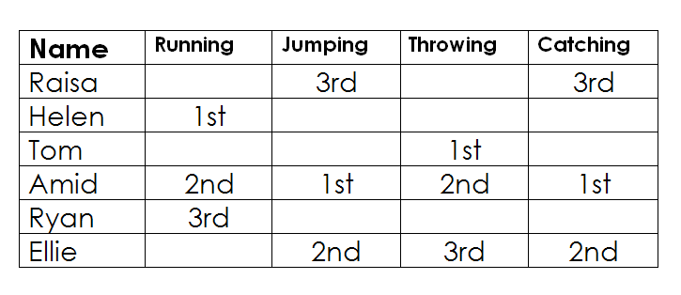
Who won the running event?

Who won most events?

How many points did Ellie have altogether?

How many points did the winner collect?

Homework
Children in a class talk about the amount of time they spend doing homework. They decide to keep a record for 3 weeks and then put their information on this chart.
Pupil Name | Number of hours doing homework each week
Pupil Name | Week 1 | Week 2 | Week 3
Sian | 8 | 3 | 8
Ramesa | 1 | 1 | 1
Richard | 7 | 4 | 7
Billie | 3 | 2 | 3
Create a block graph to show the number of hours spent by the four children doing homework during week 1.

Create another block graph to show how much homework Richard did over the 3 weeks.

(You should use squared paper to complete these graphs.)

Give a good reason why Ramesa only did 1 hour homework during weeks 1, 2 and 3.

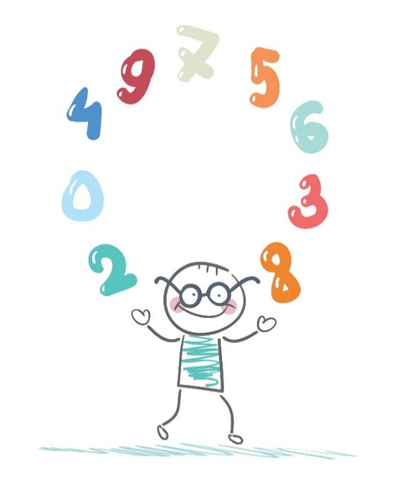

MASTERY IN MATHEMATICS
Year 4

YEAR 4 EXPECTATIONS

Year 4 Expectations
 | PV | - Round any number to the nearest 10, 100 or 1000 and decimals with one decimal place to the nearest whole number e nearest whole number
 | PV | - Count backwards through zero to include negative numbers
 | AS | - Solve addition and subtraction two-step problems in context and solve problems involving multiplication and division
 | MD | - Multiply 2-digit and 3-digit numbers by a 1-digit number using formal written layout
 | MD | - Recall all multiplication facts to 12 x 12
 | F | - Solve simple measures and money problems involving fractions and decimals to 2 decimal places
 | F | - Compare numbers with the same number of decimal places up to 2 decimal places
 | F | - Recognise and write decimal equivalents of any number of tenths or hundredths
 | F | - Add and subtract with up to 4 decimal places using formal written methods of columnar addition and subtraction
 | F | - Divide a 1 or 2-digit number by 10 or 100 identifying the value of the digits in the answer as units, tenths and hundredths
 | G | - Compare and classify geometrical shapes, including quadrilaterals and triangles, based on their properties and sizes
 | G | - Know that angles are measured in degrees and identify acute and obtuse angles and compare and order angles up to two right angles by size
 | M | - Measure and calculate the perimeter of a rectilinear figure in centimetres and metres
 | M | - Read, write and convert between analogue and digital 12 and 24 hour clocks

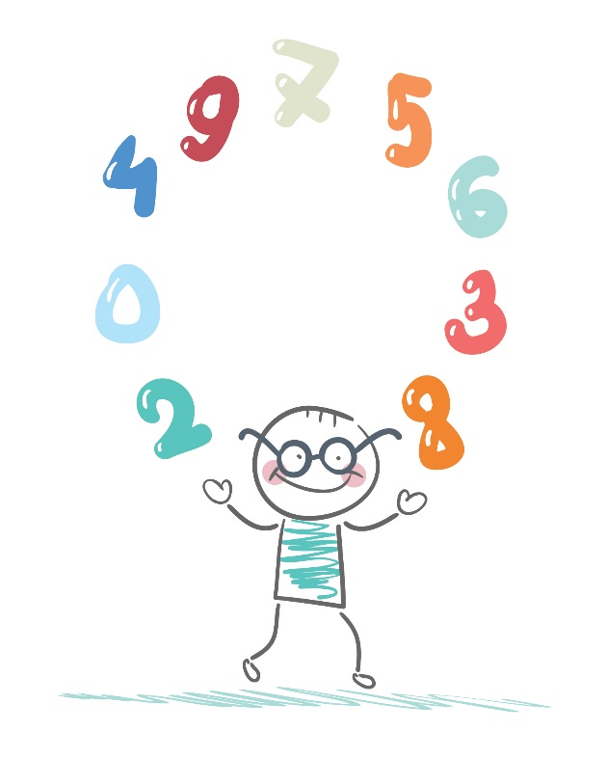
Place Value

Year 4: Place Value
Place Value | Count in multiples of 6, 7, 9, 25 and 1000.
Place Value | Find 1000 more or less than a given number. Round any number to the nearest 10, 100 or 1000.
Place Value | Count backwards through zero to include negative numbers.
Place Value | Recognise the place value of each digit in a 4-digit number (thousands, hundreds, tens, and ones). Order and compare numbers beyond 1000.
Place Value | Read Roman numerals to 100 (I to C) and know that over time, the numeral system changed to include the concept of zero and place value.
Spot the mistake
950, 975,1000,1250

What is wrong with this sequence of numbers?

True or false
324 is a multiple of 9?

What comes next?
6706+ 1000= 7706
7706 + 1000 = 8706
8706 + 1000 = 9706

Explain the order
5035, 5053, 5350, 5530, 5503
If you wrote these numbers in order, starting with the largest, which number would be third?
Explain how you ordered the numbers.

Digital value
Show the value of the digit 4 in these numbers.
3041 4321 5497
Explain how you know.

Create your own numbers
Create four-digit numbers where the digit sum is six and the tens digit is one.
eg 2211, 4110, 3210
What is the largest/smallest number you can make?

Rounding
A number, rounded to the nearest ten, is 540. What is the smallest possible number it could be? | Round 296 to the nearest 10. Round it to the nearest 100.  What do you notice?  Suggest other numbers like this.

Rounding
A number, rounded to the nearest ten, is 780. What is the smallest possible number it could be? |  | Round 797 to the nearest 10. Round it to the nearest 100.  What do you notice?  Suggest other numbers like this.
Creating 4-digit numbers

Make up a 4-digit number where the sum of the numbers is 9, e.g. 3312 or 4500.
What is the largest number you can make? | What is the second largest number you can make?
What is the smallest number you can make? | What is the second smallest number you can make?

Making up 2-digit numbers
Look at the number cards below. Using the cards make up 2 ThHTU (4-digit numbers) that are more than 1000 apart. | Look at the number cards below. Using the cards make up 2 ThHTU (4-digit numbers) that are less than 1000 apart.
9  8  5  3  4 | 9  8  5  3  4

Who is nearest?
6 children were given a maths problem where the answer was -7. Ariana wrote -15 as her answer; George wrote +3; Jemma wrote -2; Hamid wrote +1; Harry wrote -6 and Mustafa wrote zero. Who was closest to the answer and who was furthest away? | 5 children were given a maths problem where the answer was 4870. Harry wrote 3858 as his answer; wrote 4735; Jen wrote 6187; Ahmed wrote 5925 and Harriet wrote 4648. Who was closest to the answer and who was furthest away?

Creating 4-digit numbers
Create 4-digit numbers where the unit is one less than the tens and the hundreds is one less than the thousands. What is the largest possible number, and what is the smallest number, you can create?
Largest | Smallest
Create two 4-digit numbers that have a difference of more than 10 and the ones number is 9 and the hundreds number is 8?

Addition & Subtraction

Year 4: Addition and Subtraction
Add and Subtract | Add and subtract numbers with up to 4 digits using the formal written methods of columnar addition and subtraction where appropriate.
Add and Subtract | Estimate and use inverse operations to check answers to a calculation.
Add and Subtract | Solve addition and subtraction two-step problems in contexts, deciding which operations and methods to use and why.

Buying options
Andrew has to buy 3 presents for his sisters, Mary, Helen and Faye. He has a total of £50 to spend. Choose 3 presents from the list below and show how much change there will be?
Mary | Cost
Coat | £23
Jumper | £16.50
Hair Accessories | £14
Dress | £20.50
Helen
Talking Doll | £16.50
Toy Pushchair | £19.50
Doll’s House | £23.50
Toy Computer | £13.50
Faye
Large Teddy Bear | £13.50
Mini Farm | £17
Selection of Games | £15.50
Toy tape recorder | £21
Select a gift for each sister. Write the gifts below making sure that the total does not come to more than £50.
How much change will there be?

Science experiment
During a science experiment a group of children wanted to find out how far sound travels. On an open field they could hear each other over a distance of 83 metres; in a crowded street they could hear each other over a distance of 18 metres; inside a busy school they could hear each other over a distance of 6 metres; and in the middle of a wood they could hear each other over a distance of 25 metres.
Work out the difference between the distances that they could hear each other in an open field and the middle of a wood.
In which two locations could the children hear each other if they were 20 metres apart?

Dice game
I have 10 dice (1 to 6). Show three ways I can lay out the dice so that the numbers on top add up to 36.
I have 12 dice (1 to 6). Show three ways I can lay out the dice so that the numbers on top add up to 60.
The two opposite sides of a dice always add up to 7. If the top numbers of 5 dice are 4, 2, 1 5 and 5, how much will the bottom numbers add up to?

African safari
A family went on a special African safari holiday. At the resort the family were offered a number of excursions. The costs are set out below:

Excursion | Safari overnight camp | Elephant Lake | Lion Park
Adult | £250 | £120 | £60
Child | £175 | £80 | £40
Family ticket | £650 | £280 | £105

How much will it cost for a family ticket for the overnight safari and for 2 adults to go to the lion park?
Is it cheaper for a family of 2 adults and 2 children:
- to go on the overnight safari,
- or for 2 adults to go to the elephant lake and for 2 children to go to the lion park

Summer camp
Children have to buy outfits for their summer camp. Each child needs a sweat shirt; shorts and shoes. The choices are set out below.

Sweatshirt | Cost
Extra warm | £30
Cotton | £15
Wool | £24
Short sleeves | £22
Shorts
Designer | £16
White | £11
Blue | £13
With a badge | £19
Shoes
Trainers | £23
Black | £15
Sandals | £13
Jelly | £10

How much will the cheapest option cost altogether? Use the area below to show your workings.
How much will the most expensive option cost altogether? Use the space below to show your workings.
You have a budget of £50. Calculate what you can afford and show how much change you will have from £50.
True or false
Are these number sentences true or false?

6.7 + 0.4 = 6.11
8.1 – 0.9 = 7.2

Give your reasons.

Hard or easy
Which questions are easiest/hardest?
13323 - 70 =
12893 + 300 =
19354 - 500 =
19954 + 100 =
Explain why you think the hard questions are hard.

Convince me
- 666 = 8 5

What is the largest possible number that will go in the rectangular box?

What is the smallest?

Convince me

Making an estimate
Which of these number sentences have the answer that is between 550 and 600?

1174 – 611

3330 – 2779

9326 – 8777

Always, sometimes, never
Is it always, sometimes or never true that the difference between two odd numbers is odd?

4 | 1 | 4 | 3 | 3
4 | 5 | 3 | 3 | 2
4 | 5 | 3 | 3 | 3
3 | 5 | 3 | 6 | 3
3 | 2 | 3 | 3 | 4

25 dice are placed together as above. All dice have numbers 1 to 6. The number directly beneath the number seen, when added to the number seen, always adds up to 7. In other words each of the 3s seen above will have a 4 directly underneath, each of the 5s seen will have a 2 directly beneath and the 6 will have a 1 beneath, etc.
Set out the dice pattern as above but this time show the numbers underneath. For example, your first row should be 3, 6, 3, 4 and 4.
Set out the dice in any way you want in another 5 x 5 pattern so that the numbers underneath add up to 105.
Set out the dice in any way you want in a 6 x 6 pattern so that the numbers underneath add up to 125.
Set out the dice in any way you want in a 4 x 4 pattern so that the numbers underneath add up to 56.

Complicated triangles
Look at the example on the left hand side below. Complete the problem on the right hand side, putting the correct numbers in the empty squares.
64  35  75  110  29  6  104 | 91  106  69

More complicated triangles
Look at the example on the left hand side below. Complete the problem on the right hand side, putting the correct numbers in the empty squares.
6  35  75  40  29  6  46 | 22  37  15

Creating numbers
Put any 4 numbers (0-9) into the empty spaces below. Then create 4 2-digit numbers as shown below.

/

Example 62 + 38 + 64 + 28 = 192
6 | 2
3 | 8

Put 4 numbers in the spaces below so that you get as close to 100 (in the first) and 200 (in the second) as you can.

Multiplication & Division
Year 4: Multiplication & Division

Multiply and Divide | Recall multiplication and division facts for multiplication tables up to 12 × 12.
Multiply and Divide | Recognise and use factor pairs and commutativity in mental calculations.
Multiply and Divide | Multiply two-digit and three-digit numbers by a one-digit number using formal written layout.
Multiply and Divide | Solve problems involving x and +, including using the distributive law to multiply 2 digit numbers by 1 digit, integer scaling problems and harder correspondence problems such as n objects are connected to m objects.

Electric bills
The electricity bill for the school was £5,350 per year before they had solar panels. The school made a decision to buy 10 solar panels and this cut their bill to £2,100 per year. The solar panels cost £850 each.
How much did the solar panels cost altogether?
How much was the school’s electricity bill for the 10 years before they had the solar panels?
How much did they spend for the 10 years after they bought the solar panels? Don’t forget to add in the cost of buying the solar panels. (Show your working out.)

More electric bills
In a football stadium the electricity bill was £15,350 per year before they decided to buy special ‘energy saving’ lamps for their floodlights.
- The ‘energy saving’ bulbs cost £1,150 each and they had to buy 16 in total.
- After they had installed the new bulbs the electricity bill was reduced to £4,500 a year.
Work out the following:
How much did the ‘energy saving’ bulbs cost altogether?
How much was the football stadium’s electricity bill for the 5 years before they had the new energy saving bulbs?
If you consider the 5 years before the energy saving bulbs were installed and the 5 years after the energy saving bulbs were installed, how much money will the football stadium have saved? Don’t forget to add in the cost of buying the energy saving bulb. (Show your working out.)

Yet more electric bills
In a Garden Centre the electricity bill was £5,350 per year before they decided to buy special ‘energy saving’ lamps for their greenhouses.
- The ‘energy saving’ bulbs cost £150 each and they had to buy 30 in total.
- After they had installed the new bulbs the electricity bill was reduced to £1,550 a year.
Work out the following?
How much did the ‘energy saving’ bulbs cost altogether?
How much was the Garden Centre’s electricity bill for the 5 years before they had the new energy saving bulbs?
If you consider the 5 years before the energy saving bulbs were installed, and the 5 years after the energy saving bulbs were installed, how much money will the Garden Centre have saved? Don’t forget to add in the cost of buying the energy saving bulb. (Show your working out.)

Holiday time
A family are working out which is their best option for their Mediterranean holiday. The costs are set out below:
Hotel | All Inclusive for each person per week | Adult rate per day | Child Rate per day
Room | £1250 | £120 | £60
Breakfast | £1250 | £10 | £5
Lunch | £1250 | £10 | £5
Dinner | £1250 | £20 | £10
How much will it cost for a family of 4 to go ‘All Inclusive’ for one week?
Which is cheaper for a family of 2 adults and 2 children?
- To all go ‘all Inclusive’ for the week (7 days),
- Or to pay a daily rate and have breakfast; lunch and dinner each day. (Show your workings.)

How close can you get?

////
X =

Using only the digits 2, 3, 4 and 5 in the calculation above how close can you get to 200?

What is the largest product you can make?
What is the smallest product you can make?

Missing numbers
//
72 = x

Which pairs of numbers could be written in the boxes?

Making links
Eggs are bought in boxes of 12. I need 140 eggs. How many boxes will I need to buy?

Use a number fact
63 ÷ 9 = 7

Use this fact to work out:

126 ÷ 9 =

252 ÷ 7 =

Making more links
How can you use factor pairs to solve this calculation?

13 x 12

(13 x 3 x 4, 13 x 3 x 2 x 2, 13 x 2 x 6)

Prove it
What goes in the missing box?
/
6 x 4 = 512

Prove it.

How close can you get?
///
X 7

Using the digits 3, 4 and 6 in the calculation above how close can you get to 4500?

What is the largest product?

What is the smallest product?

Always, sometimes, never
Is it always, sometimes or never true that an even number divisible by 3, is also divisible by 6.

Always, sometimes, never
Is it always, sometimes or never true that the sum of four even numbers is divisible by 4.

Using the inverse
Use the inverse to check if the following calculations are correct.

23 x 4 = 92

117 ÷ 9 = 14

Greater or less than
Will the answer to the following calculations be greater or less (<, >) than 300?

152 x 2=

78 x 3 =

87 x 3 =

4 x 74 =

Multiplication triangles
Look at the example on the left hand side below. Complete the problem on the right hand side, putting the correct numbers in the empty squares.
10  5  4  20  2  6  8 | 84  63  108

Positive and negative dice
You have 2 dice. 1 is numbered 1 to 6 and the second is numbered -1 to -6.
/ | When throwing 2 dice the numbers when multiplied made -12. What were the two possible numbers you could have? | When throwing 2 dice the numbers when multiplied made -15. How many pairs of numbers could there have been? What are they?

Multiple opportunities
A football team has the option of wearing 5 different tops, 4 different shorts and 3 sets of socks. One shirt is all white, one pair of shorts is white and one pair of socks is also white.
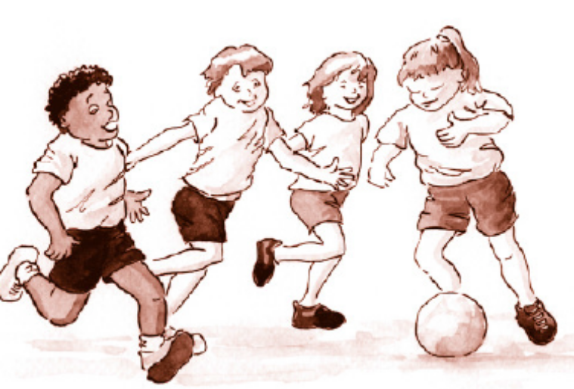 | How many possible combinations of kit can they choose for any match?
 | If they had to wear the white shorts how many combinations can they now wear?
 | If they are not allowed to wear white shirts; white shorts or white socks, how many combinations are they able to choose from?

Fractions
Year 4: Fraction
Fractions | Recognise and show, using diagrams, families of common equivalent fractions.
Fractions | Count up and down in hundredths; recognise that hundredths arise when dividing an object by a hundred and dividing tenths by ten.
Fractions | Add and subtract fractions with the same denominator.
Fractions | Recognise and write decimal equivalents of any number of tenths or hundredths; and the decimal equivalents to ⅟₄, ⅟₂ and ¾.
Fractions | Find the effect of dividing a one- or two-digit number by 10 and 100, identifying the value of the digits in the answer as ones, tenths and hundredths.
Fractions | Round decimals with one decimal place to the nearest whole number. Solve simple measure and money problems involving fractions and decimals to 2 decimal places.

The X Factor
After a special addition of the X Factor the favourite group ‘Two Boys’ had twice the number of downloads than ‘Tricia’ who had 836 downloads. ‘No Direction’ had half as many downloads as ‘Two Boys’ and ‘Tricia’ added together.
How many downloads did ‘Two Boys’ have?
How many downloads did No Direction have?

Spot the mistake
sixty tenths, seventy tenths, eighty tenths, ninety tenths, twenty tenths

… and correct it.

What comes next?
83/100, 82/100, 81/100, ….., ….., …..

31/100, 41/100, 51/100, ….., …..,

What do you notice?
1/10 of 100 = 10
1/100 of 100 = 1
2/10 of 100 = 20
2/100 of 100 = 2

How can you use this to work out: 6/10 of 200
6/100 of 200?

True or false
1/20 of a metre= 20cm

4/100 of 2 metres = 40cm

Find an example
Give an example of a fraction that is more than a half but less than a whole.

Now give another example that no one else will think of.

Explain how you know the fraction is more than a half but less than a whole. (Draw an image.)

Greater than or less than
Put the correct symbol < or > in each box

3.03 3.33

0.37 0.32

Adding or subtracting
What needs to be added to 3.23 to give 3.53?

What needs to be added to 3.16 to give 3.2?

Do, and then explain
Circle each decimal which when rounded to the nearest whole number is 5.

5.3 5.7 5.2 5.8

Explain your reasoning.

Odd one out
Which is the odd one out in each of these trios?

3/4 9/12 4/6

9/12 10/15 2/3

Why?

What do you notice?
Find 4/6 of 24

Find 2/3 of 24

What do you notice?

Write any other similar statements.

Complete the pattern
Complete the pattern by filling in the blank cells in this table:

1/10 | 2/10 | 3/10
10/100 | 20/100 |  | 40/100
0.1 |  | 0.3

Finding decimal places
Write a decimal number (to one decimal place) which lies between a half and three quarters.

Ordering
Put these numbers in the correct order, starting with the smallest.

1/4 0.75 5/10

Explain your thinking

What do you notice?
5/5 – 1/5 = 4/5

4/5 – 1/5 = 3/5

What do you notice?
11/100 + 89/100 = 1

12/100 + 88/100 = 1

13/100 + 87/100 = 1

Continue the pattern for the next five number sentences

Undoing
I divide a number by 100 and the answer is 0.3. What number did I start with?

Approximate answer
Write down a number with one decimal place which, when multiplied by 10, gives an answer between 120 and 130.

Approximate answer
Write down a number with one decimal place which when multiplied by 10 gives an answer between 120 and 130.

Measures
Year 4: Measures

Measures | Convert between different units of measure (e.g. kilometre to metre). Solve problems involving converting from hours to minutes; minutes to seconds; years to months; weeks to days).
Measures | Measure and calculate the perimeter of a rectilinear figure (including squares) in centimetres and metres. Find the area of rectilinear shapes by counting squares.
Measures | Estimate, compare and calculate different measures, including money in pounds and pence.
Measures | Read, write and convert time between analogue and digital 12 and 24-hour clocks.

Healthy eating café

A new healthy eating café has just opened and this is its menu.
Starters | Cost
Goat cheese salad | £2.50
Melon and grapefruit cocktail | £2.25
Prawn cocktail | £2.45
Vegetable soup | £2.10
Main meal
Tomato pasta bake | £5.50
Chicken salad | £6.75
Tuna salad | £6.90
Vegetable curry | £5.50
Dessert
Yogurt | £1.50
Rice pudding | £1.75
Muesli | £2.00
Select a meal, which includes a starter, main meal and dessert costing you £15 or less?
How much change you will have from £15 (it may be 0p).

Holiday planning
When considering where to go on holiday in May, a family decided to check on the temperature, rainfall and the time it takes to get to different European cities so as to help them make up their mind where to go. The following chart gives details of their findings.

City | Time to get there (hours) | Rainfall  (mm) | Temp (°c)
Paris | 2 | 12 | 16
Munich | 3 | 8 | 15
Antalya | 5 | 1 | 28
Athens | 5 | 1 | 25
Oslo | 4 | 18 | 6

Mum wants a hot climate (at least more than 20) and isn’t concerned about how long it takes to get there. What choices does she have?
Dad doesn’t want to travel for more than 3 hours. What choices does he have?
Their son likes long flights but hates warm weather. Where could he choose to go?
Their daughter wants to go somewhere where she is not travelling more than 3 hours and where the rainfall is no more than 10mm. Where will she choose?

Ordering measures
Put these amounts in order starting with the largest.

Half of three litres
Quarter of two litres
300 ml

Explain your thinking.

Undoing
Saya’s swimming lesson lasts 50 minutes and it takes 15 minutes to change and get ready for the lesson. What time does Imran need to arrive if his lesson finishes at 6.15pm?

Explain thinking
The time is 10:35 am.
Jack says that the time is closer to 11:00am than to 10:00am.

Is Jack right?
Explain why.

Write more statements
One battery weighs the same as 60 paperclips;
One pencil sharpener weighs the same as 20 paperclips.
How many pencil sharpeners weigh the same as a battery?

Testing conditions
If the width of a rectangle is 3 metres less than the length, and the perimeter is between 20 and 30 metres, what could the dimensions of the rectangle be?

Convince me.

Buying tickets
Adult tickets cost £8 and children’s tickets cost £4.
How many adult and children’s tickets could I buy for £100 exactly?

Find more than one way of doing this.

Always, sometimes, never
If you double the area of a rectangle, you double the perimeter.

Working backwards
Put these times of the day in order, starting with the earliest time.

A: Quarter to four in the afternoon

B: 07:56

C: six minutes to nine in the evening

D: 14:36

The answer is…
The answer is … 225 metres
What is the question?

What do you notice?
What do you notice?
1:00pm = 13:00
2:00pm = 14:00

Continue the pattern

Geometry
Year 4: Geometry
Geometry | Compare and classify geometric shapes, including quadrilaterals and triangles, based on their properties and sizes.
Geometry | Identify acute and obtuse angles and compare and order angles up to two right angles by size.
Geometry | Identify lines of symmetry in 2-D shapes presented in different orientations.
Geometry | Complete a simple symmetric figure with respect to a specific line of symmetry.
Geometry | Describe positions on a 2-D grid as coordinates in the first quadrant. Describe movements between positions as translations of a given unit to the left/right and up/down.
Geometry | Plot specified points and draw sides to complete a given polygon.

Creating Patterns
Create an interesting pattern that includes at least 2 horizontal, 2 vertical and another set of parallel lines.

Design a Badge
Design a special badge by using at least 2 horizontal, 2 vertical and another set of parallel lines.

Design a sports badge by using at least 2 horizontal, 2 vertical and another set of parallel lines.
Visualising
Imagine a square cut along the diagonal to make two triangles.
Describe the triangles.
Join the triangles on different sides to make new shapes.
Describe them. (You could sketch them.)
Are any of the shapes symmetrical?
Convince me.

Symmetry
Draw a non-right angled triangle with a line of symmetry.

Always, sometimes, never
Is it always, sometimes or never true that the two diagonals of a rectangle meet at right angles?

Criteria of polygons
Show or draw a polygon that fits both of these criteria.

”Has exactly two equal sides.”
”Has exactly two parallel sides.”

What do you look for?

Convince me
John says that he can draw a right angled triangle which has another angle which is obtuse.
Is he right?
Explain why.

Working backwards
Here are the co-ordinates of corners of a rectangle which has width of 5.
(7, 3) and (27, 3)
What are the other two co-ordinates?

Statistics
Year 4: Statistics

Stats | Interpret and present discrete and continuous data using appropriate graphical methods, including bar charts and time graphs.
Stats | Solve comparison, sum and difference problems using information presented in bar charts, pictograms, tables and other graphs.

Cleaning teeth
A group of children has created this table to show how long they spend brushing their teeth each day over a three-day period.
Pupil Name | Number of minutes brushing teeth each day
Pupil Name | Day 1 | Day 2 | Day 3
Mary | 5 | 2 | 8
Aysha | 1 | - | 2
Nick | 4 | 2 | 8
Tessa | 3 | 2 | 3
Which child spends most time brushing his/her teeth over the three days?
Give a good reason why Aysha didn’t record any time on Day 2.
Put, in order, which child spends the longest to the shortest amount of time brushing his/her teeth.
1___________ 2 __________ 3 __________ 4 __________

Teachers’ cars
There are 6 teachers’ cars on the school car park. The table below shows how many miles each car has travelled, how old it is and how much it is worth.

Car | Mileage | How old  (years) | Value
Mr Ace | 13, 000 | 2 | £10,500
Mrs Bean | 23, 500 | 6 | £7,000
Ms Cold | 24, 500 | 8 | £4,500
Miss Eve | 5,500 | 3 | £17,500
Mr Frank | 1,500 | 1 | £22,000
Ms Gas | 25,000 | 9 | £1,500

Create the following graphs using any form you like.
- Create a graph to show the mileage covered by the cars.
- Create another graph to show the cars’ values
- Create a third graph to show the age of the cars.

Keeping healthy and exercise
A group of children have created this table to show how they keep healthy by exercising. They show their best score in three different events.
Pupil Name | Number completed in a minute
Pupil Name | Star Jumps | Sit ups | Press ups
Mary | 16 | 8 | 10
Aysha | 18 | 10 | 12
Nick | 29 | 20 | 28
Tessa | 13 | 2 | 3
Which child is best at all three?
Which exercise seems to be the most difficult?
Order the children according to their total score.
1___________ 2 __________ 3 __________4 __________

World’s tallest buildings
Class 3 did an investigation about tall buildings in different cities across the world. They started by looking at the tallest building in the UK and then compared it with 6 of the world’s tallest buildings. Here is their chart:
Building Name | Height (m) | Number of floors
The Shard, London | 306 | 72
Burj Khalifa | 828 | 163
Shanghai Tower | 632 | 121
Makka Tower Hotel | 601 | 120
One World Trade Centre | 541 | 104
CTF Finance Centre | 530 | 111
Taipei 101 | 509 | 101
Create the following graphs using any form you like.

- Create a graph to show the number of floors in each hotel.

- Create another graph to show the height of each hotel.

- How much taller is the Makka Tower Hotel than the Shard in London?

- How many extra floors does the Shanghai Tower have compared with the Shard?

Roman soldiers
Roman soldiers moved between different forts. As can be seen from the table below each fort had soldiers that were there all year. Extra soldiers were brought in for the summer or winter months.
Roman Fort | Number of soldiers in each fort
Roman Fort | All Year | October to March only | April to September only
Ambleside | 3500 | 800 | 1000
Chester | 18000 | 100 | 1200
Castleshaw | 2900 | 200 | 280
Wreay | 1300 | 200 | 350
Which fort held the most soldiers?
How many soldiers were there in Wreay fort in January?
Calculate how many soldiers were in each fort in July and put them in order (largest first).
1___________________________ 2 ___________________________ 3 ___________________________4 ___________________________

World’s longest rivers
Class 7 did an investigation about the world’s longest rivers. Here is a chart of their findings:

River | Length(m) | Continent
Nile | 4,180 | Africa
Amazon | 3,912 | South America
Mississippi - Missouri | 3,710 | North America
Chang Jeng (Yangtse) | 3,602 | Asia
Ob | 3,459 | Europe
Huang Ho | 2,900 | Asia
Yenisei | 2,800 | Europe
Parana | 2,795 | South America
Irtish | 2,758 | Europe
Zaire | 2,716 | Africa
*For the sake of this table Russia has been included in Europe.

How much longer is the Nile than the Yenisei?
Which is the longest river in Asia?
Using squared paper create a graph showing the 10 rivers by length and colour code them according to their continent.

